**CHAPTER I**

**INTRODUCTION**

This system provides estimator with core knowledge and skill for developing realistic cost estimates suited to their organizations project. Accurately forecasting the cost of future projects is vital to the survival of any business or organization contemplating future construction. Cost estimators develop the cost information that business owners or managers, professional design team members, and construction contractors need to make budgetary and feasibility determinations. From an Owner's perspective the cost estimation may be used to determine the project scope or whether the project should proceed. The construction contractor's cost estimation will determine the construction bid or whether the company will bid on the construction contract. Construction cost estimators can be contractually hired in many different ways. They may be employed by the owner's representative or project manager, employed by the construction manager, employed as a member of a professional design team, or separately hired by the owner. They estimate building costs through all the stages of design and the construction of the project. On large projects it is common for estimators to specialize in disciplines that parallel design discipline specialization. It is very important to have the cost estimator involved right from the start of the project to ensure that the project budget reflects the decisions made by the rest of the project team throughout the integrated design processes.

**1.1 Objectives of the project**

The main objectives of this project are as follow:

* To enable the estimator’s easy to calculate the home building information
* To inform the building flow information for single _ storey
* To save time consuming, paper works and man-power

**1.2 Scope of the proposed system**

The scopes of proposed system are as follow:

* View home page
* View building flow information
* Upload new data for the price of raw materials
* Edit and delete for existing raw materials data
* Calculate number of raw materials needed and price for single _storey
* View total building result for single _storey
* Upoad new data for user login
* Edit and delete for existing members data

**1.3 The input and output of the system**

There are many input and output in this system .Estimator must insert updated price of raw materials, inserting, deleting and searching.

**1.4 Function of the System**

There are two types of function for estimating cost of building for single _storey system. They are functions for raw materials and functions for calculate. The functions for estimator are as follows.

**1.4.1 Functions of Estimator for Edit Raw Materials**

* Login
* View building flow
* Update by name
* Insert by name and price
* Delete by name
* Search by name
* Exit

**1.4.2 Functions of Estimator for Calculate**

* Login
* Calculate Pegout
* Calculate Hardcore and Sand Filling
* Calculate Column
* Calculate Beam
* Calculate Floor
* Calculate Wall
* Calculate Room
* Calculate Door and Window
* Calculate Ceiling
* Calculate Paint
* Calculate Roofing Truss Work
* View Building Total Result for Single_storey

**1.4.3 Function of Estimator for Login**

* Update by username and password
* Insert by username and password
* Delete by username and password
* Search by username and password
* Exit

**1.5 Hardware Requirements**

* 1.7GHz Intel Core™ i3-4005U CPU processor or later
* 2GB RAM or more
* 10 GB of free hard disk space

**1.6 Software Requirements**

* Microsoft Access 2007
* Microsoft Visual Studio 2010
* 32-bit Operating System

**1.7 Organizations of the Project**

The organizations of the project are as follows:

The introduction to the project, objectives, scope and functions of the proposed system are described in Chapter 1.

Chapter 2 describes the design of the project. It includes system flow diagram and sequence diagram for each user. It also includes the database design of the proposed system.

The implementation steps of the project are stated in Chapter 3.

In Chapter 4, conclusions, advantages of the system, limitations and future works of the project are presented.

**CHAPTER 2**

**DESIGN OF ESTIMATING COST OF BUILDING FOR SINGLE STOREY**

In this system, it is mainly described for only one user: Estimators. It is designed with system flowchart diagram, use case diagram, sequence diagrams for update raw materials, update member and calculate estimating cost of building for single _storey.

**2.1 Flow Diagram for Common Function**

The estimator of the system needs to login to enter into this system. After logged into the raw materials site, he or she can view only estimator information. The administrator can create raw materials name and price, and delete or edit raw material name and price.

Login

Start

**No**

Check(username& Password)

Yes

Calculate cost of Building

Update information for Login

Update raw materials information

View about Us

View building flow

Database

End

**Figure 2.1 System Flowchart Diagram**

**2.2 Use case diagram**

Use case diagram for estimate cost of building system can be used only by estimator. If estimator enter login with valid account (username and password), he or she can view building flow. And then estimator calculate estimating cost of building. In this system, estimator can update raw materials of name and price. If not, try again the password.

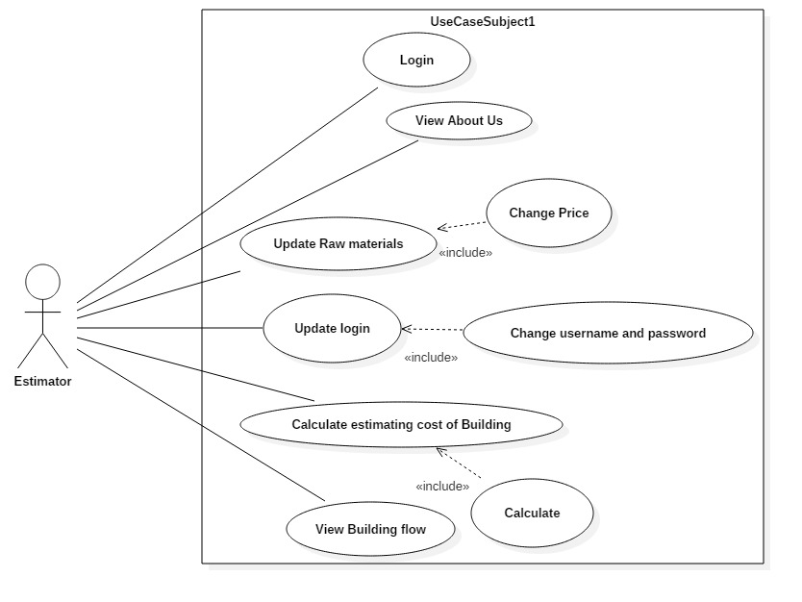**Figure 2.2 Use case diagram for estimator**

**2.3 Sequence Diagram of Estimator for Update raw materials**

The sequence diagram is intended to estimator for updating raw material information. The estimated cost of building system is used by only estimators. Estimators who want to use the system firstly need to login (username and password). The system will check whether username and password are valid or not. If login is unsuccessful, the system returns the invalid message and retry again. And then, the system check again. If login is successful, the estimator view building flow and return. And then, estimator can update, insert, delete raw materials information (or) name and price of raw materials. Estimator can search raw materials name and price.

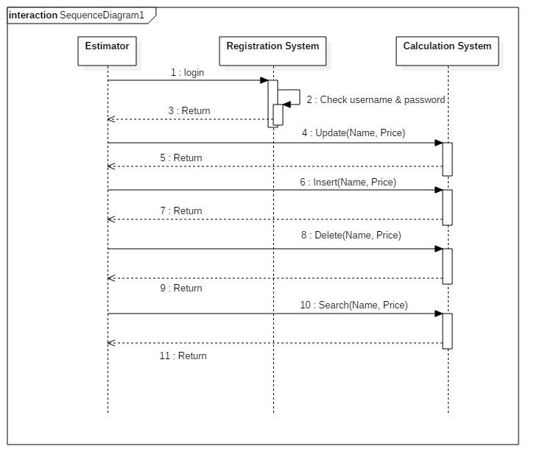**Figure 2.3 Sequence Diagram of Estimator for Update raw materials**

**2.4 Sequence diagram of Estimator for Calculate**

The sequence diagram is intended to estimators for calculate cost of building. The estimators who want to calculate the cost of building for each part such as Pegout, Column, Beam, Floor, Wall, Roof, Room, Door and Window, Plastering, Stair, Hardcore, Sand Filling, Earth Work, Topping, Celling, Paint, Gutter and Pipe. And then he or she can view the result of building cost for single _storey.

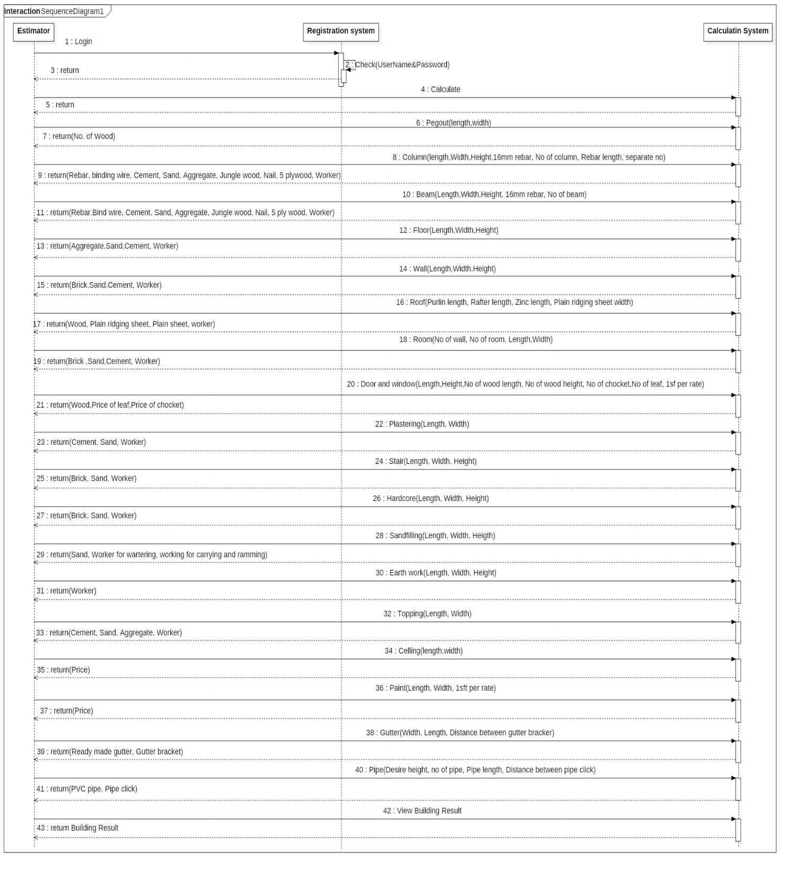

**Figure 2.4 Sequence Diagram for Estimator Calculate**

**2.5 Sequence diagram of estimator for Update username and password**

The sequence diagram is intended to estimator for updating raw material information. The estimated cost of building system is used by only estimators. Estimators who want to use the system firstly need to login (username and password). The system will check whether username and password are valid or not. If login is unsuccessful, the system returns the invalid message and retry again. And then, the system check again. And then, estimator can update, insert and delete member’s information.

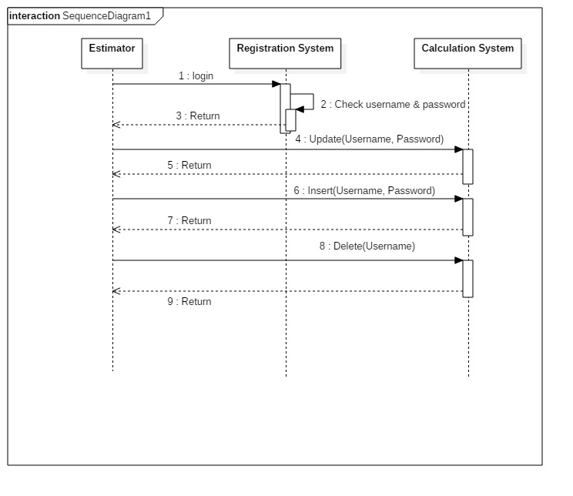

**Figure 2.5 Sequence Diagram of Estimator for Update username and password**

**2.6 Database Table**

In this system, there are mainly two database tables. There are Login table and Raw material table.

**2.6.1 Login Table**

The login table is shown as follows. There are two attributes in this table. These are user name and password. The type of username and password is text.

|  |  |
| --- | --- |
| **Attribute Name** | **Type** |
| Username | Text |
| Password | Text |

**Table 2.1 Login Table**

**2.6.2 Raw Materials Table**

The raw material table is shown as follows. There are four attributes in this table. These are MaterialName, MaterialPrice, TotalNumber, and TotalPrice. The types of MaterialName is text, MaterialPrice is number, TotalNumber is number and TotalPrice is number.

|  |  |
| --- | --- |
| **Attribute name** | **Type** |
| MaterialName | Text |
| MaterialPrice | Number |
| TotalNumber | Number |
| TotalPrice | Number |

**Table 2.2 Raw Materials Table**

**CHAPTER 3**

**IMPLEMENTATION OF THE PROJECT**

**3.1 Estimator Login Page**

In Figure 3.1, Estimator must give the corrected username and password to use this system. Then, they can enter to the system by pressing ‘Login’ button. If login is unsuccessful, the system returns the invalid message and retry again. If login is successful, the estimator can see the home form of estimating cost of building for single _storey.



**Figure 3.1 Estimator Login Page**

**3.2 Home Page of Estimating Cost of Building for Single _Storey Page**

In this Figure 3.2, a home page will be appeared when estimator’s login is successful. At home page, user can see the radio button view building flow, edit material, calculate, about as and edit member. From this page, user can perform his or her desire function. Then he/she can click **OK** button.

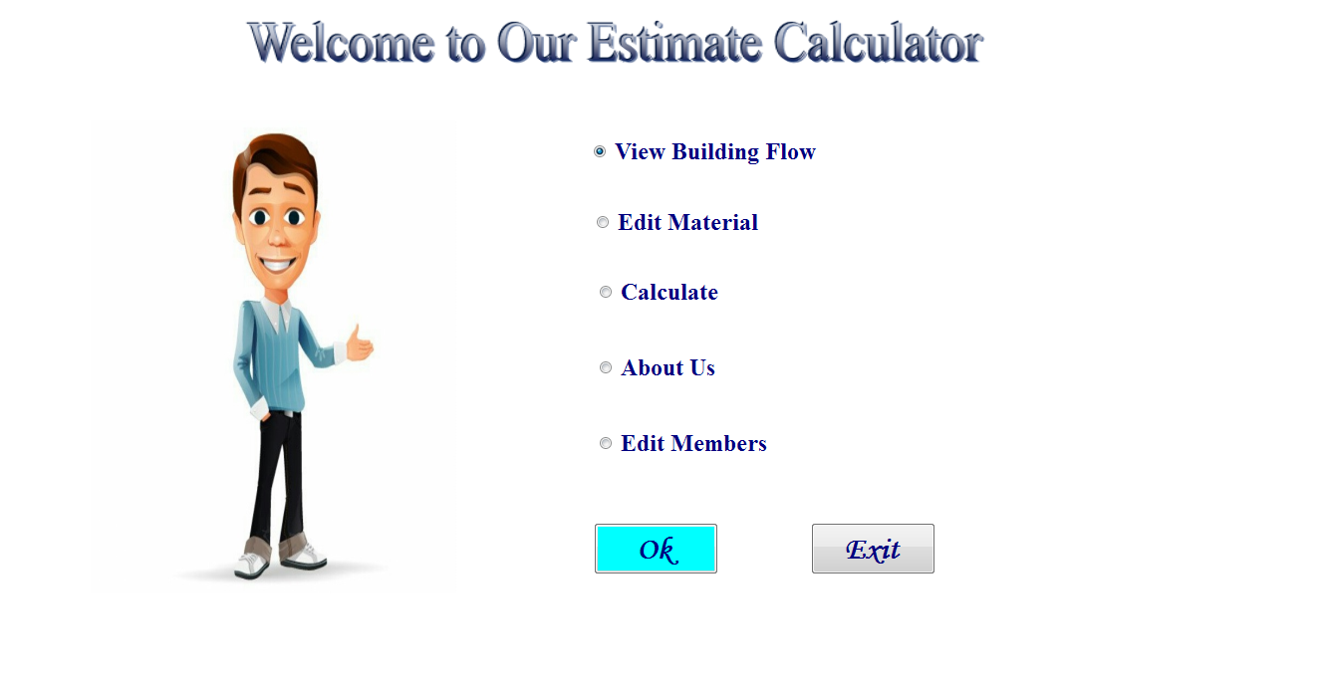

**Figure 3.2 Home Page**

**3.3 View Building Flow Page of Estimating Cost of Building for Single _Storey**

The view building flow page will be shown as in Figure 3.3. The estimator can view the building flow information (step by step) for single _storey. After completing using the services, he/she can back to the home page.

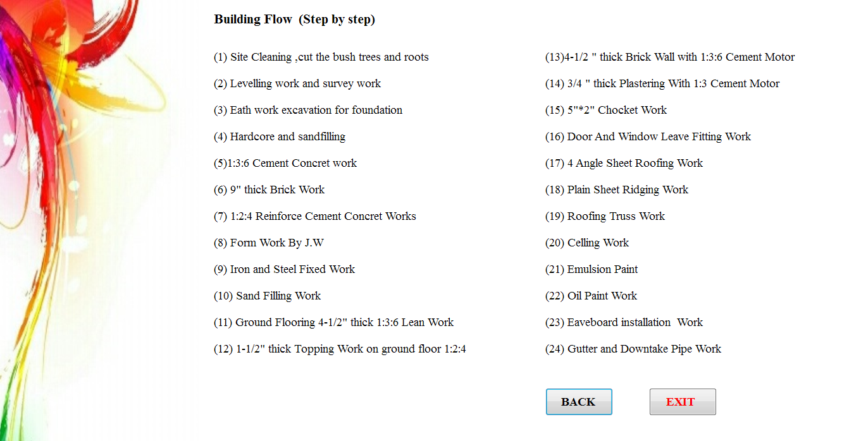

**Figure 3.3 View Building Flow Page**

**3.4 Edit Material Page of Estimating Cost of Building for Single _Storey**

In the figure 3.4, this form will be appeared when the estimator choose the radio button “Edit material”. In this page the estimator can view the existing raw materials data with the data grid view. Another way he or she can select the raw material. After that they can see existing each raw material name and related price. The estimator who want to upload new information to the raw material table, they can click the “Insert” button. More over the estimator who want to edit and delete the existing raw materials information from the raw material table, the can click the “Edit” and “Delete” button. After completing using the services, he or she can back to the home page.

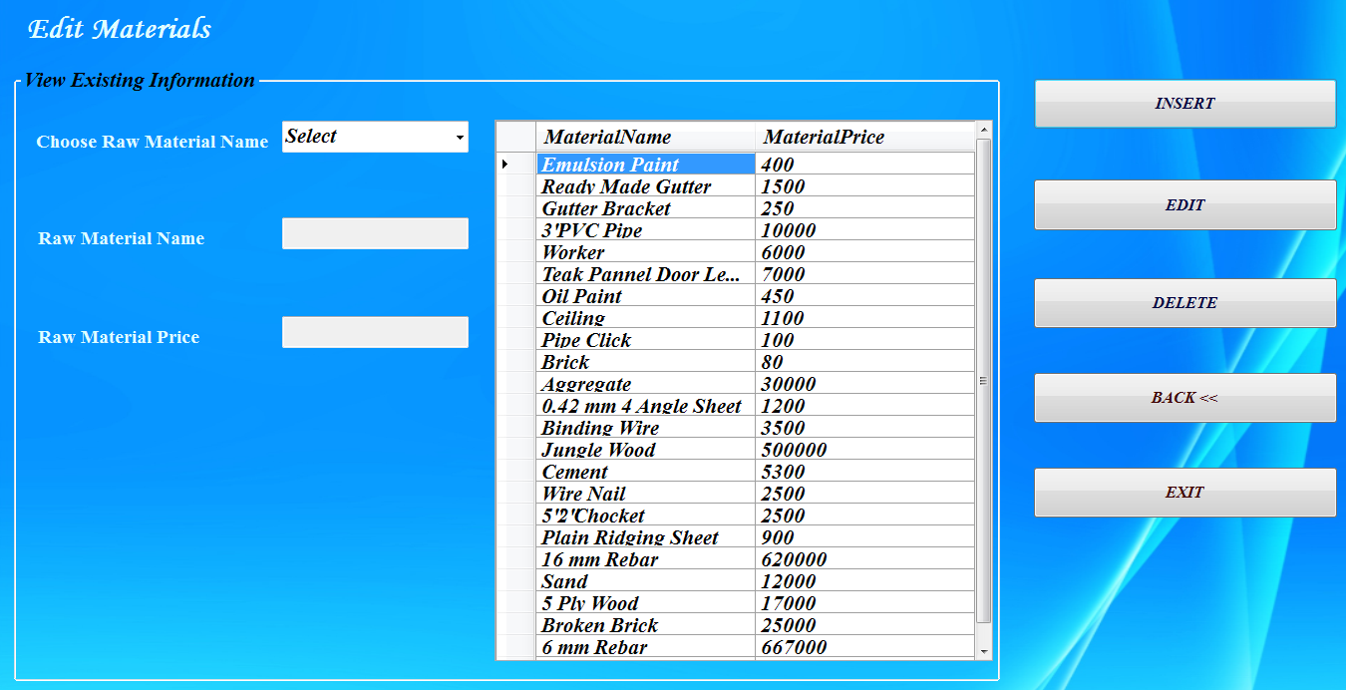

**Figure 3.4 Edit Material Page**

**3.4.1 Insert New Materials Page**

The estimator’s insert new raw materials information page will be shown as in Figure 3.5. In insert new raw materials page, the estimator can add new information. He/she must fill out the insert new raw materials form. Then he/she click **save** button to insert the information of new raw materials. To insert new information, he/she must need to fill the related form and then click **save** button. After completing using the services, he or she can back to the home page.

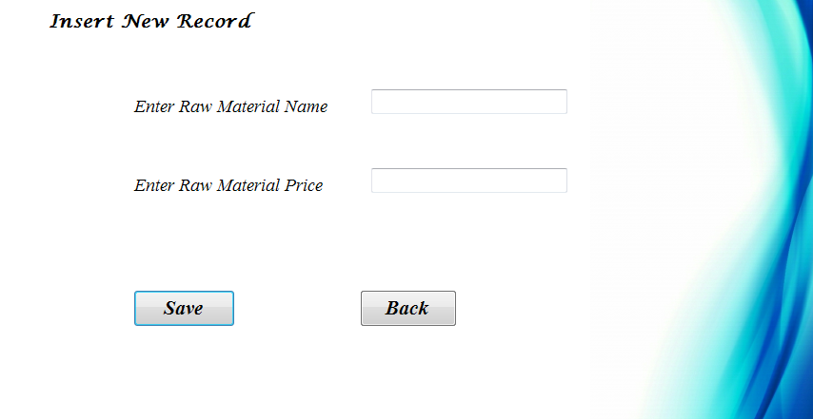

**Figure 3.5 Insert New Materials Page**

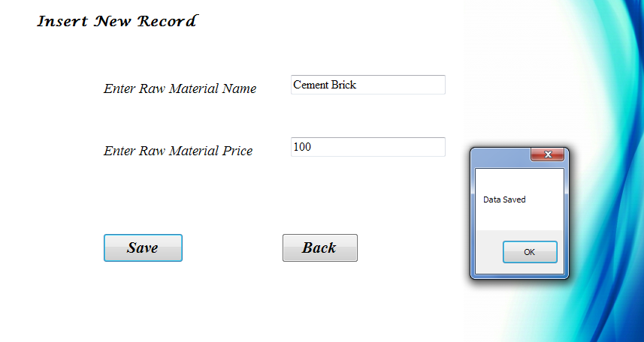

**Figure 3.6 Viewing Result of Insert New Materials Page**

**3.4.2 Edit Raw Materials Page**

In the edit raw materials page as in Figure 3.7, this form will appeared when the estimator click the “Edit” button. The estimator can view all exiting raw materials name and price. And then he/she can edit these raw materials information by clicking **Update** button. The corresponding output will appear in figure 3.8. After completing using the services, he or she can back to the home page.

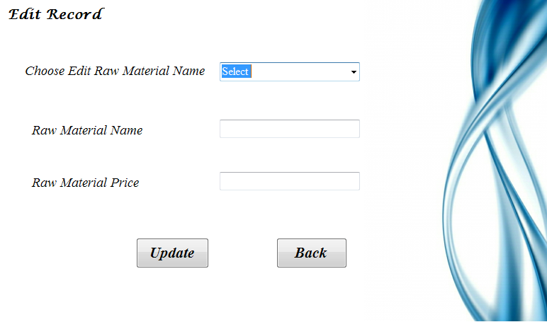

**Figure 3.7 Edit Raw Materials Page**

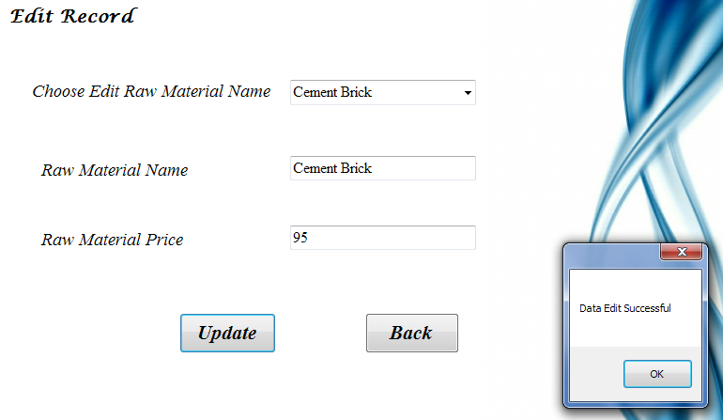

**Figure 3.8 Viewing Result of Edit Raw Materials Page**

**3.4.3 Delete Raw Materials Page**

In the delete page as in Figure 3.9, if the estimator wants to delete raw materials, he or she choose raw materials name and then click **Delete** button. And then the corresponding output will appear in figure 3.9. After completing using the services, he or she can back to the home page.

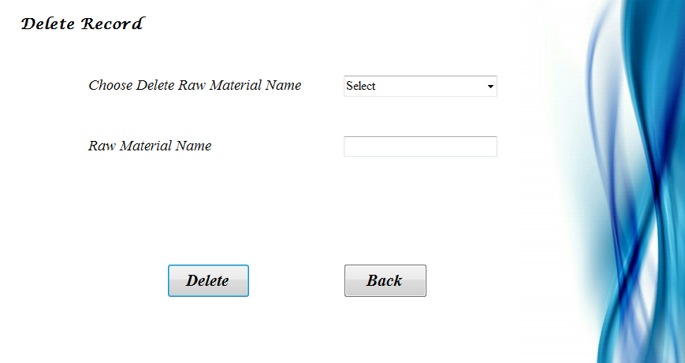

**Figure 3.9 Delete Raw Materials Page**

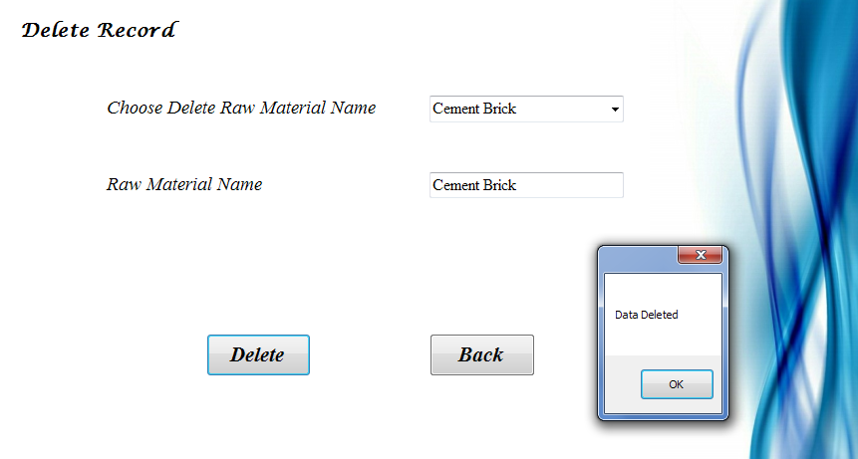

**Figure 3.10 Viewing Result of Delete Raw Materials Page**

**3.5 Calculate for Single _Storey Form**

In this figure 3.11, this form will be appeared when the estimator choose the radio button “calculate”. In this page, he or she can calculate the each part of building cost for single _storey. After they calculate each part of building cost, the estimator can view the total estimate cost of single _storey. After completing using the services in our system, he/she can back to the home page.

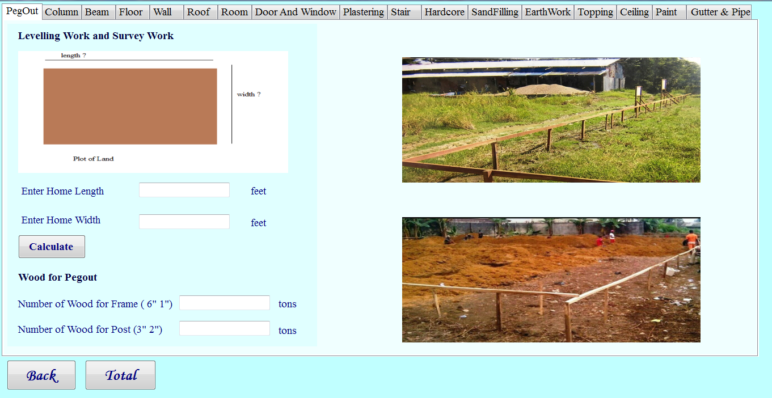

**Figure 3.11 Calculate for Single _Storey Form**

**3.5.1 PegOut Form**

In this figure 3.12, this form will be appeared when the estimator select the “Pegout” tab control. In this page the estimator can calculate the cost of only pegout work. The estimator must enter the home’s width and length. And then he or she may click the calculate button. And then the corresponding output will appear as shown in figure 3.13. In this page, the estimator can see the number of wood for frame (6’ 1”) and the number of wood for post (3’ 2”).



**Figure 3.12 PegOut Form**

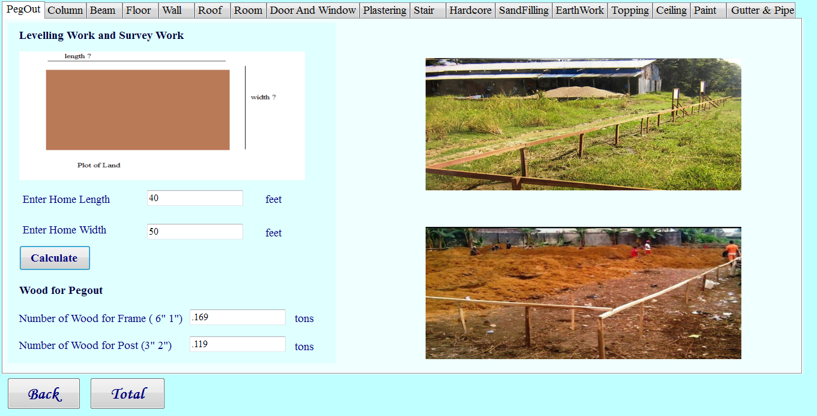

**Figure 3.13 Viewing Result of PegOut Form**

**3.5.2 Calculate Column Form**

In this figure 3.14, this form will be appeared when the estimator select the “column” tab control .In this page the estimator can calculate the cost of only column work. The estimator can enter the column width, length, height, 16mm rebar for 1 column and number of column. And then he or she may click the “calculate” button. After that he or she can see the number of raw materials for column work such as number of rebar (16mm), number of rebar (6mm), number of binding wire ,number of cement, number of sand, number of aggregate, number of jungle wood, number of nail, number of 5 plywood, number of worker. Moreover the estimator can calculate the column footing work. When the estimator calculate the footing cost, they may enter the rebar length, separate number and number of column. And then he or she may click the “calculate” button. After that he or she can see the number of raw materials for column footing work such as number of rebar and number of binding wire. The corresponding output will appear as shown figure 3.15.

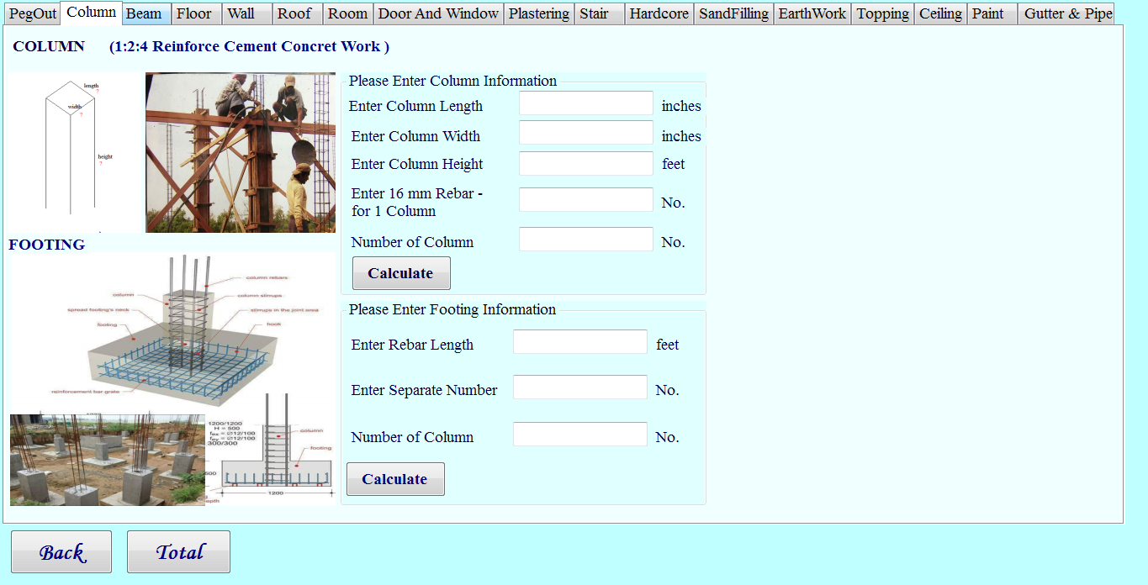

**Figure 3.14 Column Form**

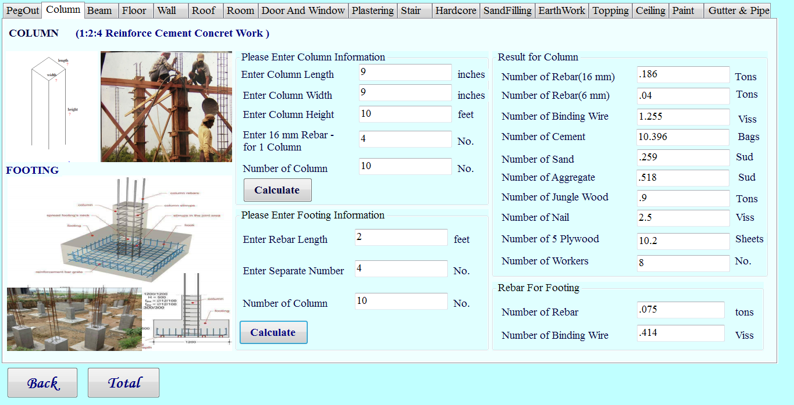

**Figure 3.15 Viewing Result of Column Form**

**3.5.3 Calculate Beam Form**

In the figure 3.16, this form will be appeared when the estimators select the “Beam tab control. In this page the estimator can calculate the cost of only beam work. When the estimators click the GB, PS (2 sides) link, they can see the beam form for 2 sides, this form is shown in figure 3.16. In this page, the estimator can enter the beam length, width, height, 16mm rebar for 2 sides beam and number of beam. Moreover, the estimator can select the FB, RB (3 sides) link. At that time, the estimator can see the beam form for 3 sides page, this form is shown in figure 3.17. In this page the estimator can enter the beam length, width, height, 16mm rebar for 3 sides beam. And then he or she can click the “calculate” button. After that he or she can see the number of raw materials for beam work such as number of rebar (16mm), number of rebar (6mm), number of binding wire, number of cement, number of sand, number of aggregate, number of jungle wood, number of nail, number of 5 ply wood, number of workers. The corresponding output will appear as shown in figure 3.19.

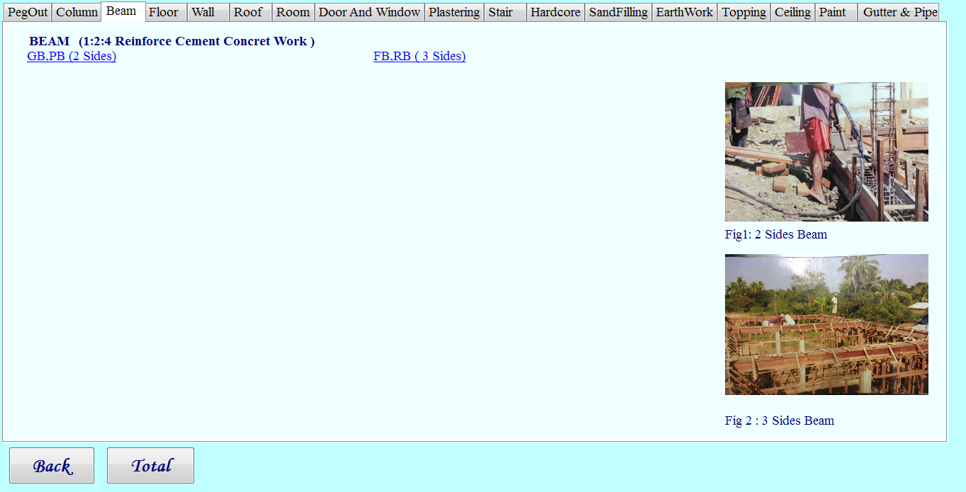

**Figure 3.16 Beam Form**

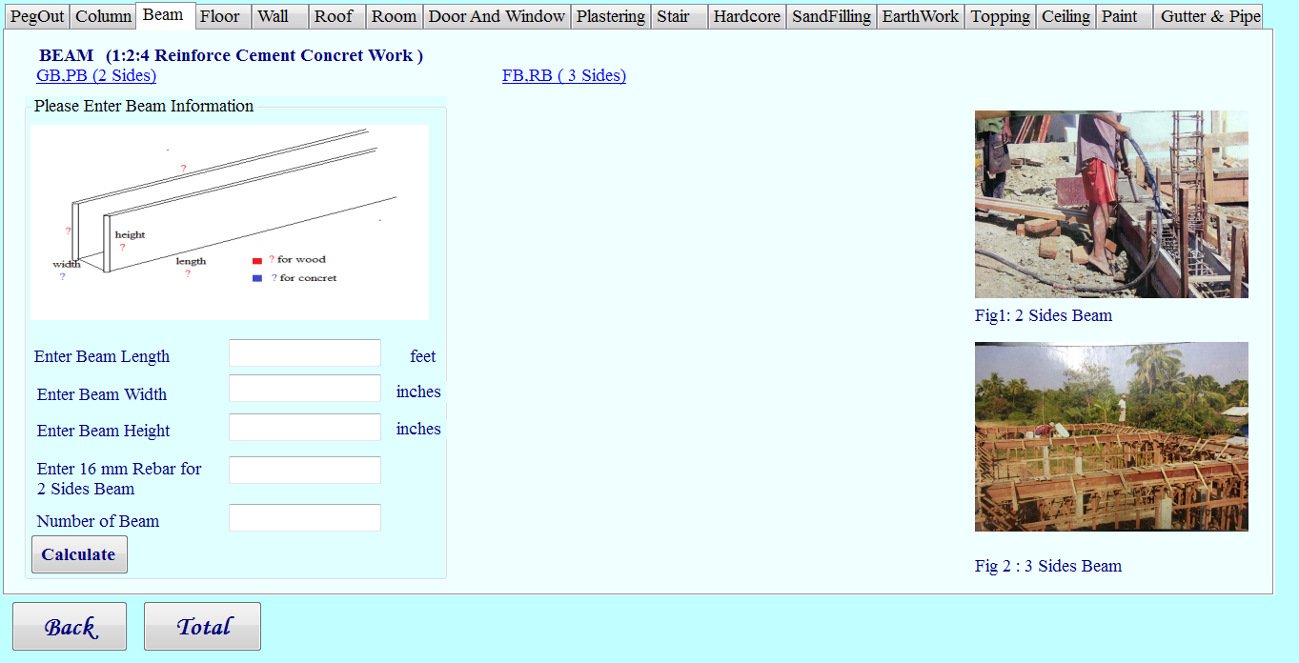 **Figure 3.17 Beam Form for 2 Side**

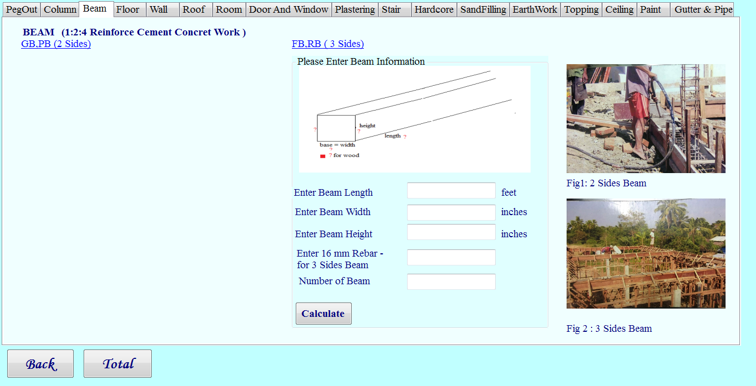

**Figure 3.18 Beam Form for 3 Side**

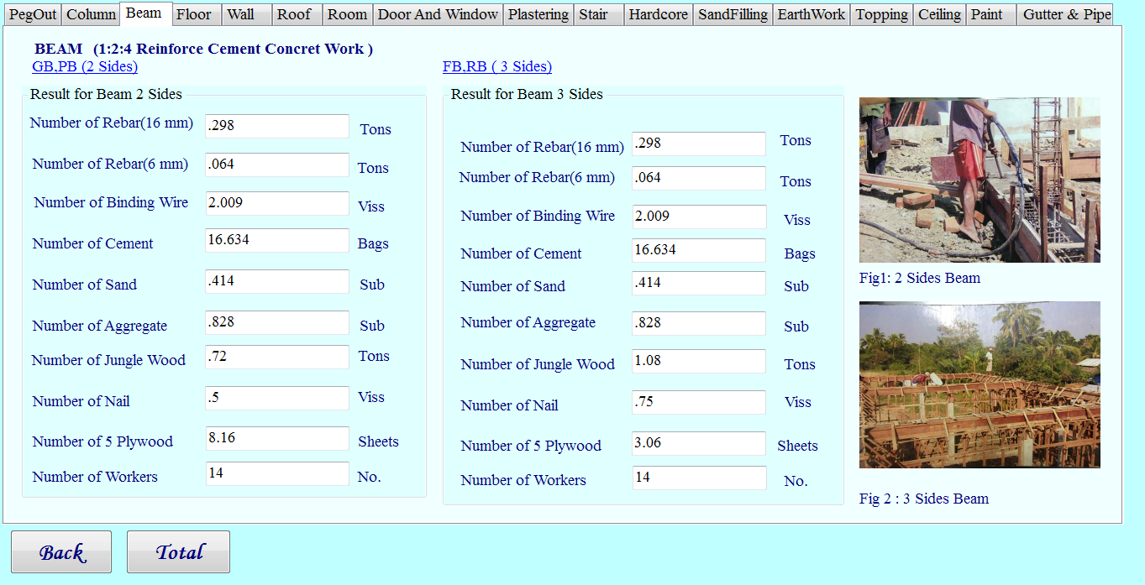

**Figure 3.19 Beam Result Form**

**3.5.4 Calculate Floor Form**

In the figure 3.20, this form will be appeared when the estimator select the “floor” tab control. In this page, he or she can calculate the ground flooring 4” thick 1:3:6 cement concert work and 1:3:6 cement concert (Lean work). The estimator can enter the length, width, height for ground flooring 4” thick 1:3:6 cement work (Lean work).After that he or she can click the “calculate” button. And then the corresponding output will appear in figure 3.20. In this page, the estimator can see the number of raw materials for floor work such as number of cement, number of sand, number of aggregate and number of worker. The corresponding output will appear as shown in figure 3.21.

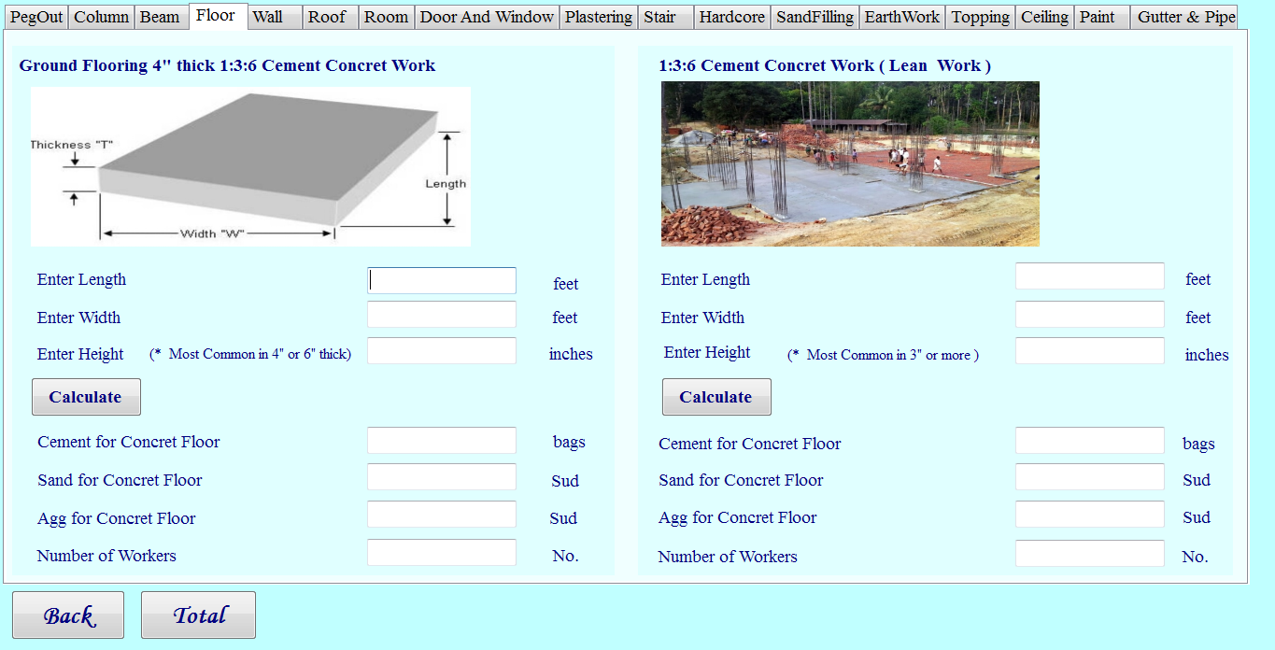

**Figure 3.20 Floor Form**

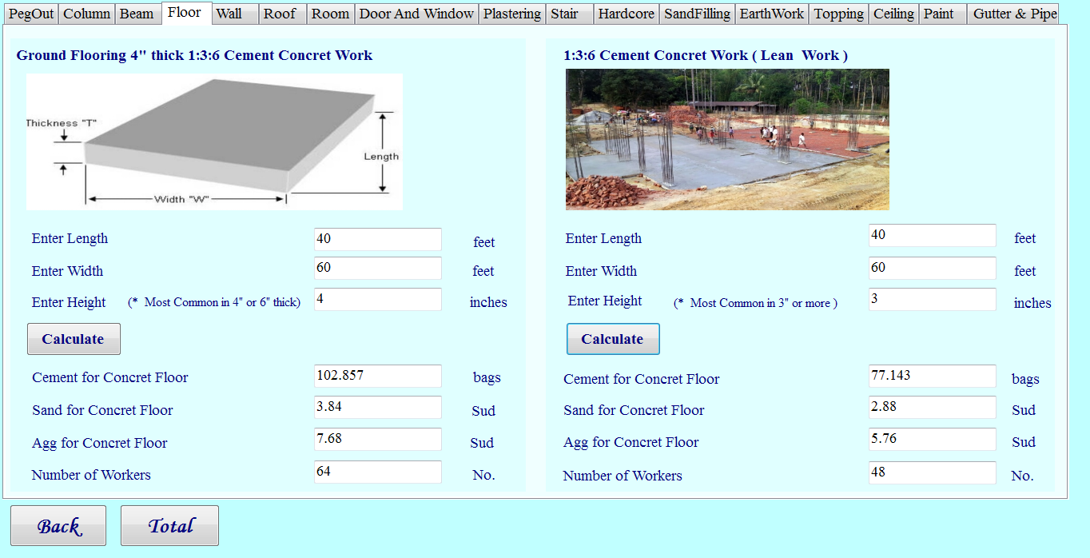**Figure 3.21 Viewing Result of Floor Form**

**3.5.5 Calculate Wall Form**

When the estimator can enter the calculate page, he /she can see the calculate wall form. In this page the estimator must enter the 4-1/2’’ thick for wall (length, width) and 9” or more thick for wall (length, width, height). And then he /she may click the calculate button. This form is shown in figure 3.22. After that he / she can see the number of raw materials such as number of brick, number of cement, number of sand, number of worker for 4-1/2” thick wall and 9” thick wall. The corresponding output will appear as shown in figure 3.23.

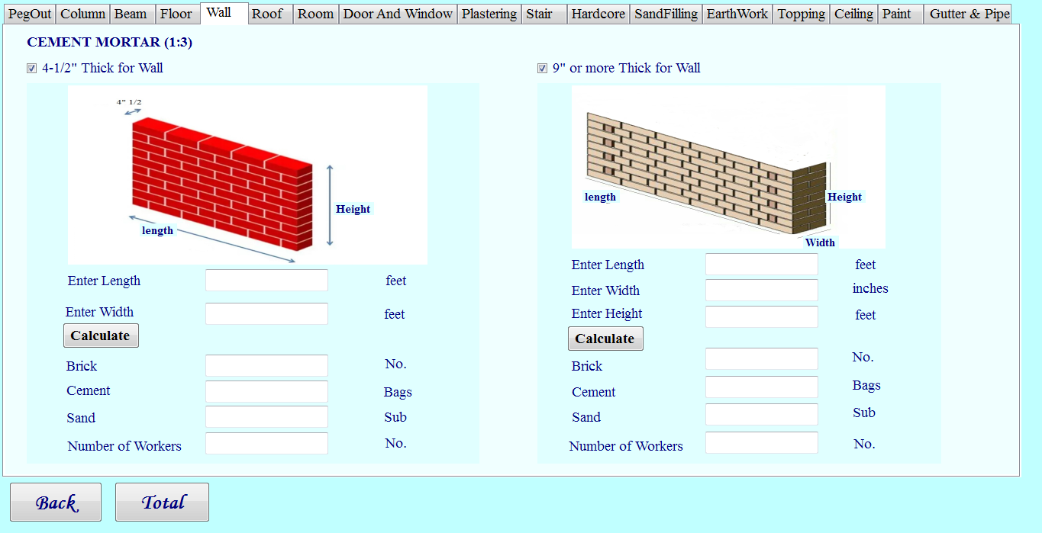

**Figure 3.22 Wall Form**

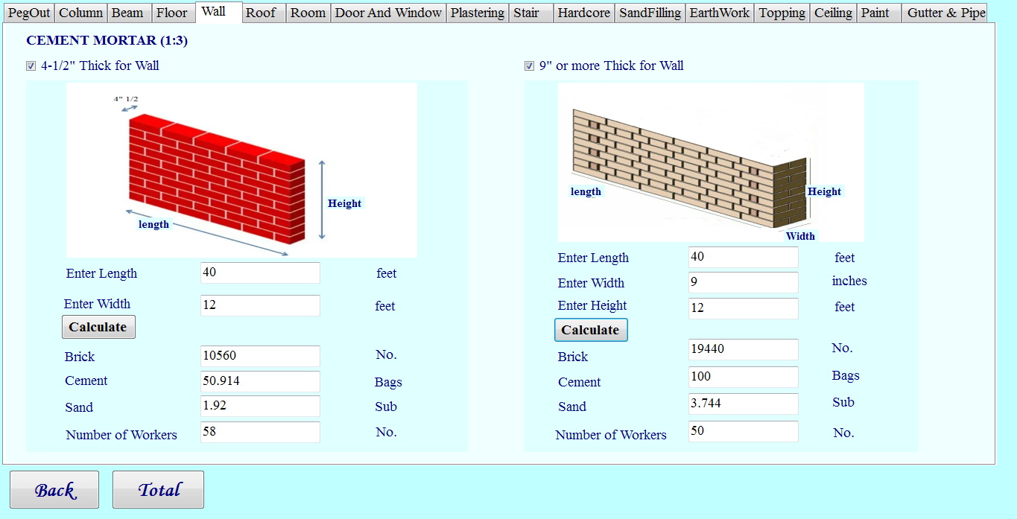

**Figure 3.23 Viewing Result of Wall Form**

**3.5.6 Calculate Roof Form**

In the figure 3.24, this form will be appeared when the estimator select the “Roof” tab control. In this page the estimator can calculate the cost of only column work. The estimator can enter the purlin length, rafter length, 4 angle sheet length, 1 Rft for plain Ridging sheet. And then he or she can click the “calculate” button. After that he or she can see the number of raw materials for roof work such as number of 2’ 2” wood for purlin, number of 4’ 2” wood for rafter, number of 8’ 8” wood for evaeboard installation, number of 4 angle sheet, number of plain ridging sheet, price for plain ridging sheet, number of worker. The corresponding output will appear as shown in figure 3.25.

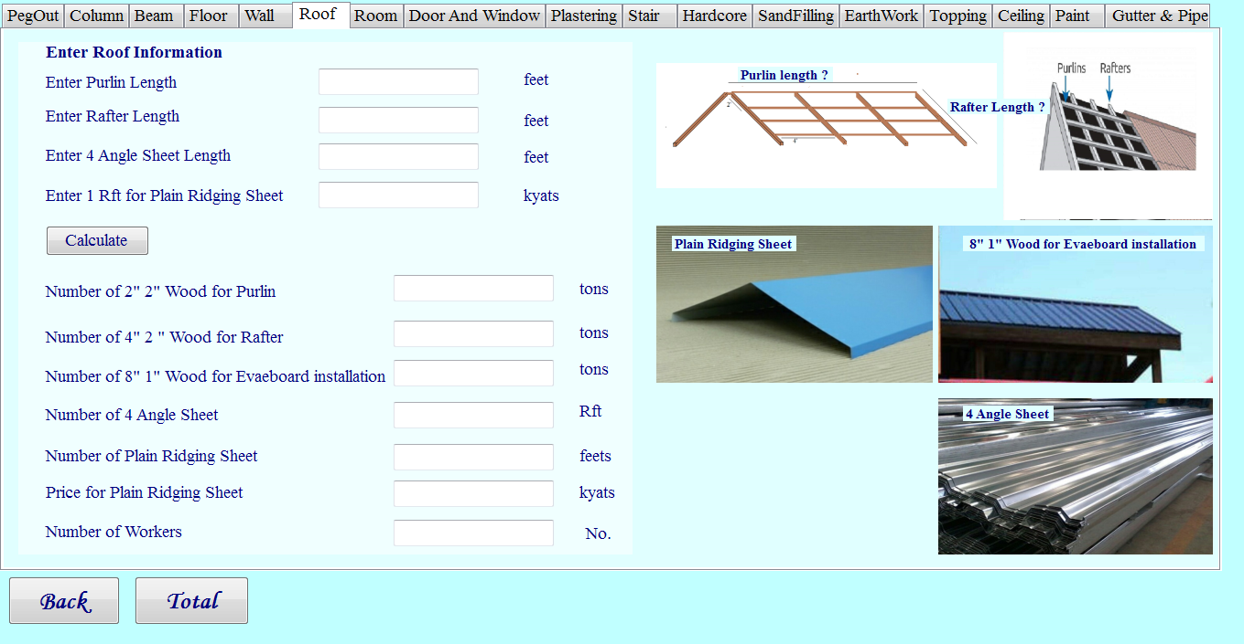

**Figure 3.24 Calculate Roof Form**

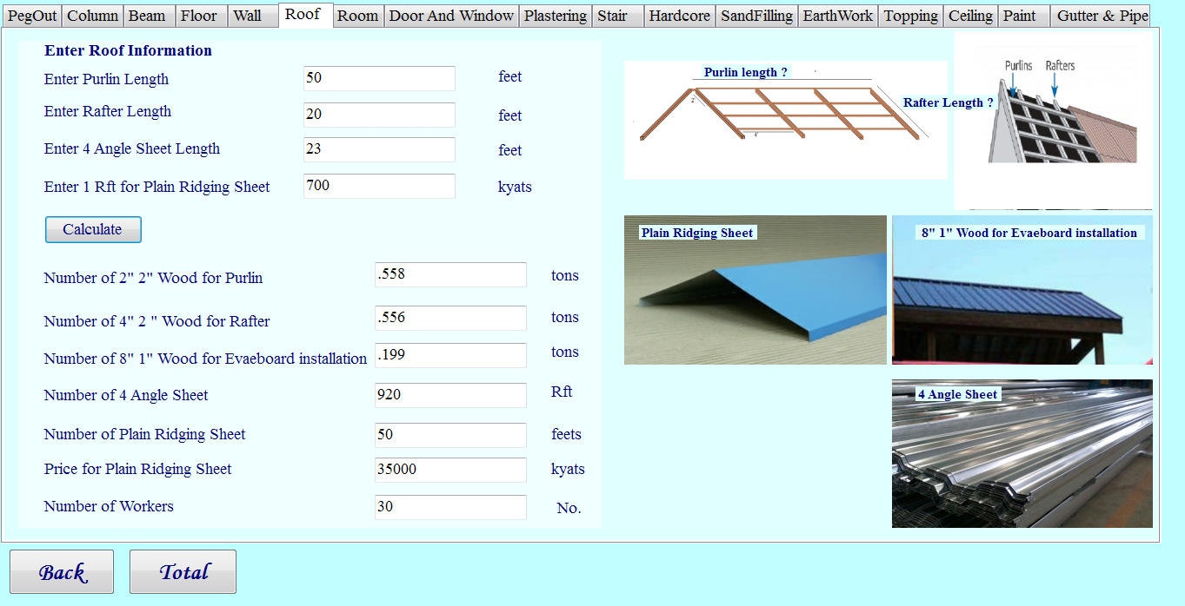

**Figure 3.25 Viewing Result of Calculate Roof Form**

**3.5.7 Calculate Room Form**

When the estimator can enter the calculate page, he /she can see the calculate room form. In this page the estimator must enter the room information (length, width, height, number of room) and he /she can choose the number of wall (2 side or 3 side or 4 side). And then he /she may click the calculate button. This form is shown in figure 3.26. After that he / she can see the number of raw materials for room such as number of brick, number of sand, number of cement, number of worker. The corresponding output will appear as shown in figure 3.27.

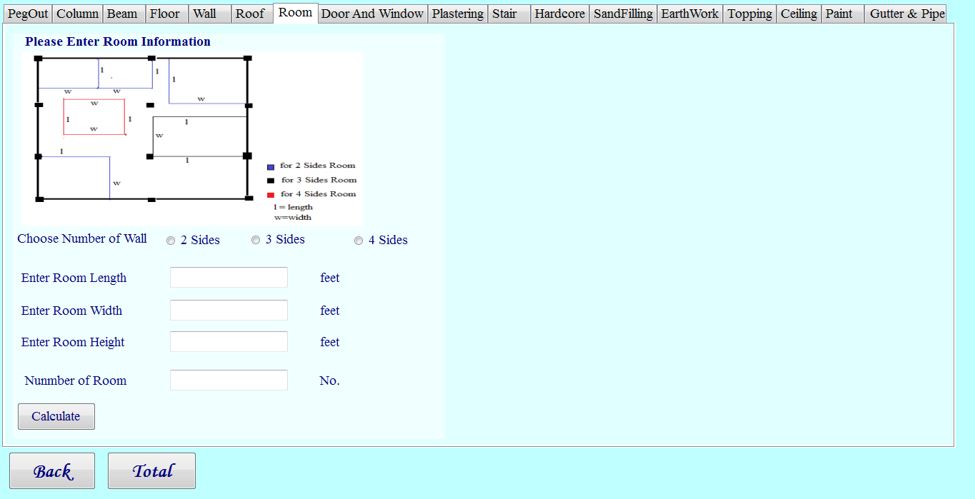

**Figure 3.26 Calculate Room Form**

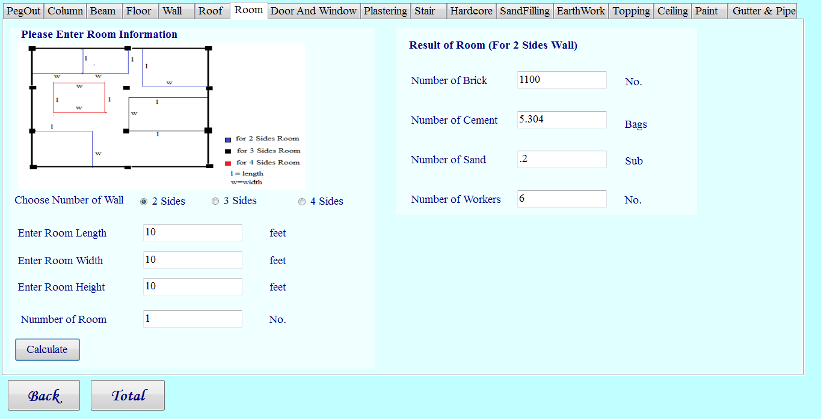

**Figure 3.27 Viewing Result of Calculate Room Result Form**

**3.5.8 Calculate Door and Window Form**

When the estimator can enter the calculate page, he /she can see the calculate door and window form. In this page the estimator can enter the door and window information (length, height, number of wood length ,number of wood height, number of leaf, number of chocker and 1 sft per rate).Moreover, he /she can click the chocket for window button , chocket for door button, leaf for window button and leaf for door button. And then he or she may click the “calculate” button. This form is shown in figure 3.28. After that he / she see the number of raw materials for door and window such as number of wood, window leaf price and door leaf price. The corresponding output will appear as shown in figure 3.29.

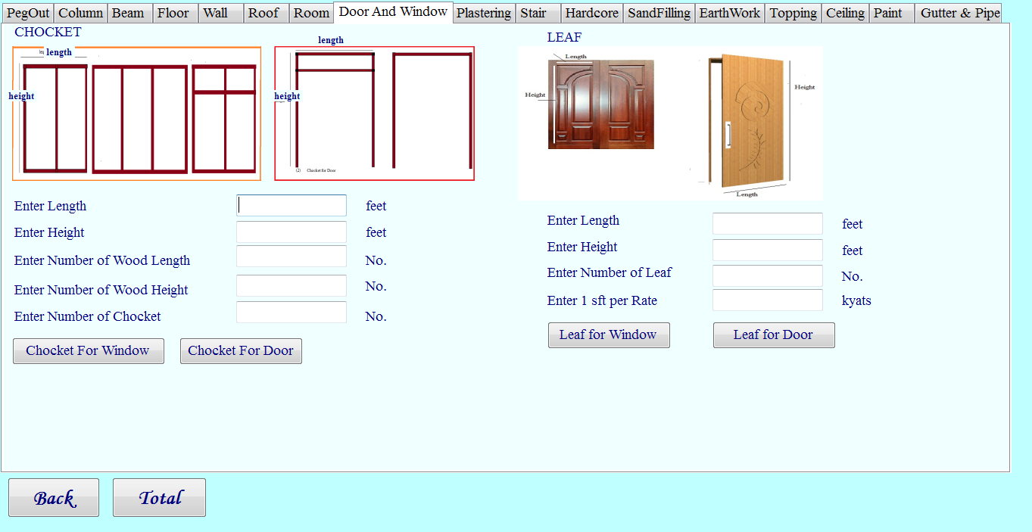

**Figure 3.28 Calculate Door and Window Form**

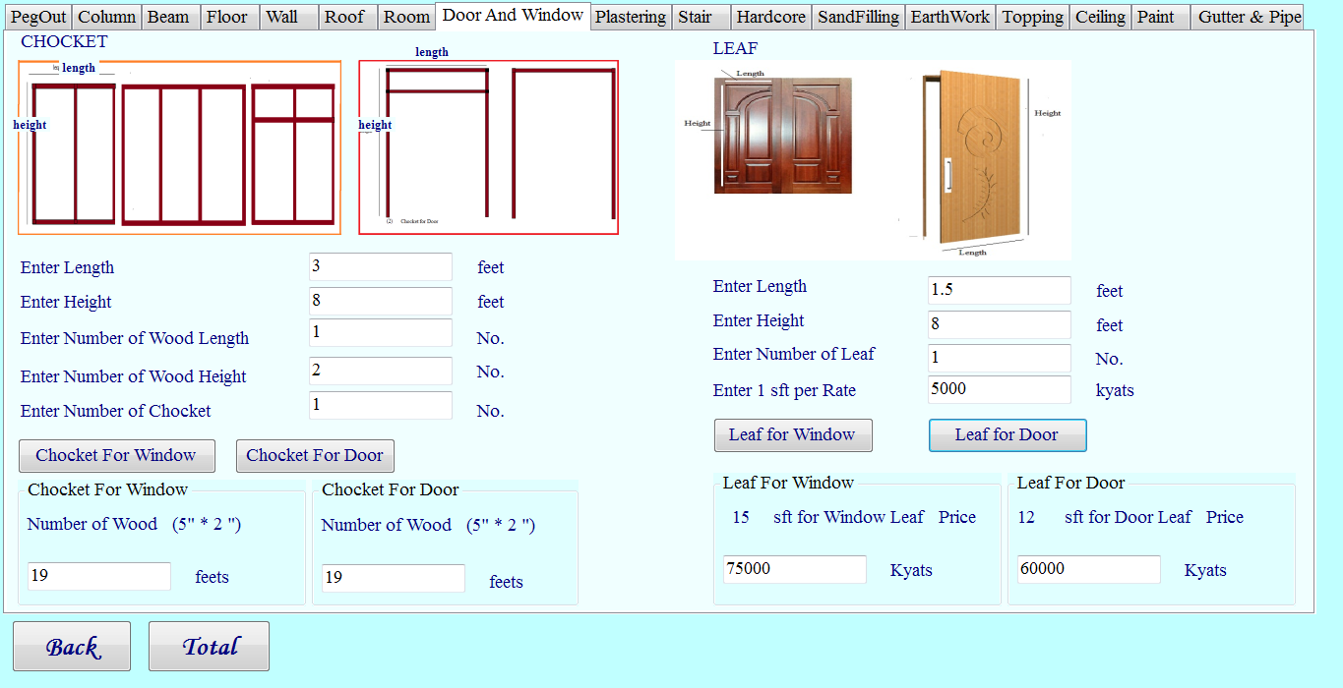

**Figure 3.29 Viewing Result of Door and Window Form**

**3.5.9 Calculate Plastering Form**

When the estimator can enter the calculate page, he /she can see calculate the plastering form. In this page the estimator must enter the plastering information (length and width). And then he /she may click the calculate button. This form is shown in figure 3.30. After that he / she can see the number of raw materials for plastering such as number of cement, number of sand, number of worker. The corresponding output will appear as shown in figure 3.31.

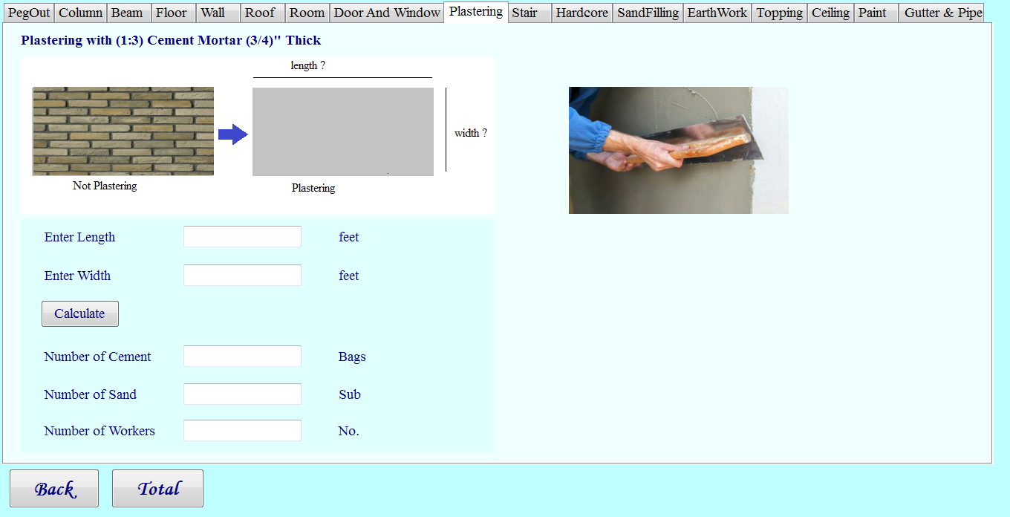

**Figure 3.30 Calculate Plastering Form**

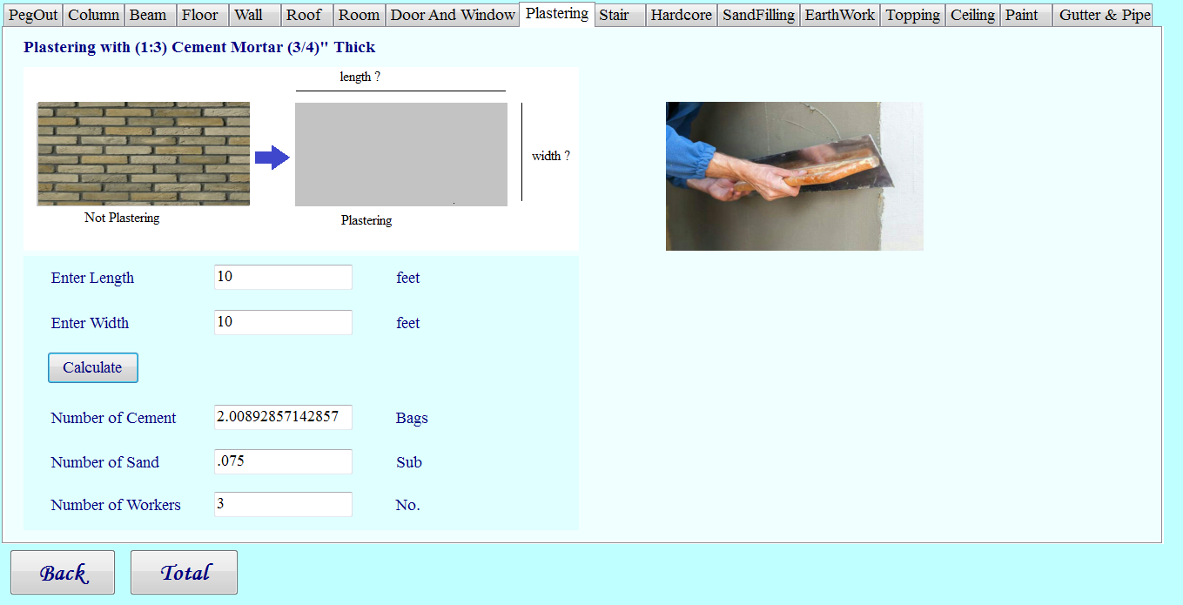

**Figure 3.31 Viewing Result of Plastering Form**

**3.5.10 Calculate Stair Form**

When the estimator can enter the calculate page, he /she can see the calculate stair form. In this page the estimator must enter the stair information (length and width, height). And then he /she may click the calculate button. This form is shown in figure 3.32. After that he / she can see the number of raw materials for stair such as number of brick, number of cement, number of sand. The corresponding output will appear as shown in figure 3.33.

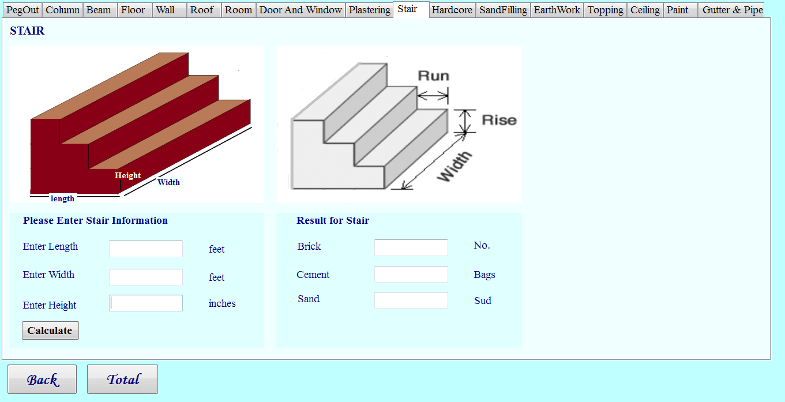

**Figure 3.32 Calculate Stair Form**

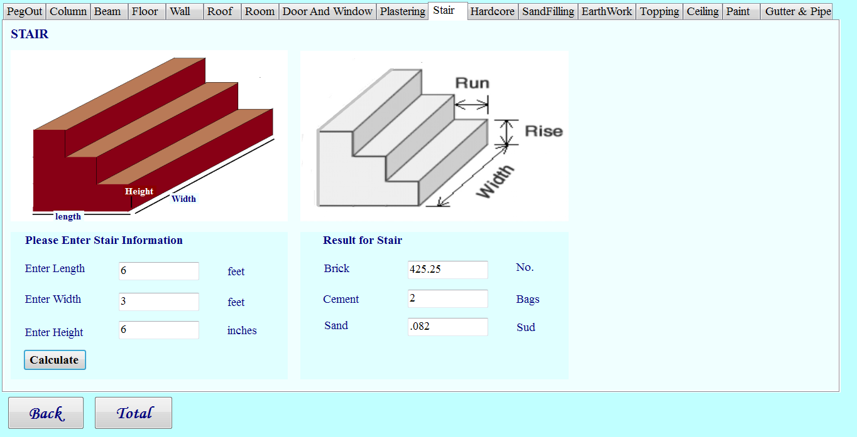

**Figure 3.33 Viewing Result of Stair Form**

**3.5.11 Calculate Hardcore Form**

When the estimator can enter the calculate page, he /she can see the calculate stair form. In this page the estimator must enter the plastering information (length and width, height). And then he /she may click the calculate button. This form is shown in figure 3.34. After that he / she can see the number of raw materials for hardcore such as number of broken brick, number of sand, number of worker. The corresponding output will appear as shown in figure 3.35.

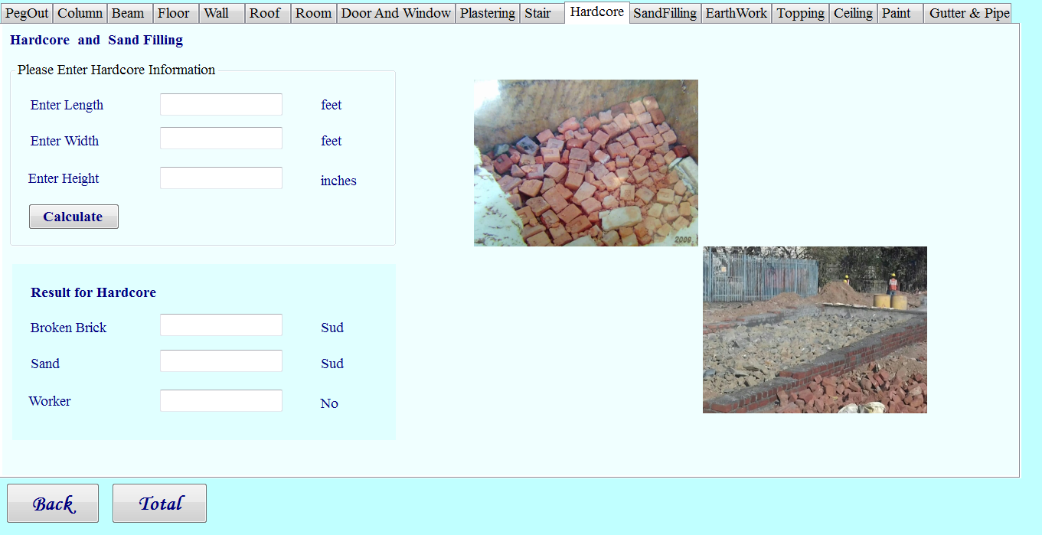

**Figure 3.34 Calculate Hardcore Form**

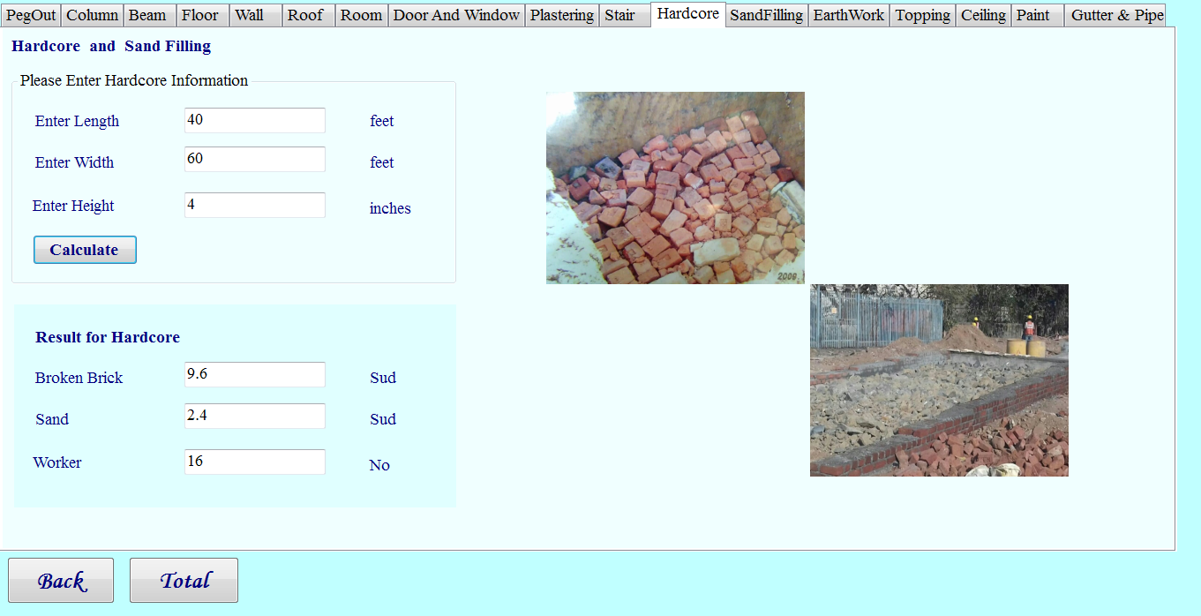

**Figure 3.35 Viewing Result of Calculate Hardcore Form**

**3.5.12 Calculate Sand Filling Form**

When the estimator can enter the calculate page, he /she can see calculate sand filling form. In this page the estimator must enter the sand filling information (length and width, height). And then he /she may click the calculate button. This form will be appear as shown in figure 3.36. After that he / she can see the number of raw materials for sand filling such as number of sand, worker for watering, worker for carrying and ramming. The corresponding output will appear as shown in figure 3.37.

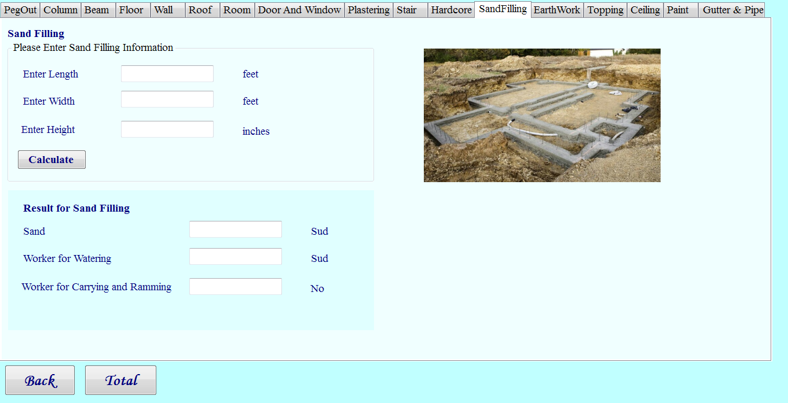

**Figure 3.36 Calculate Sand Filling Form**

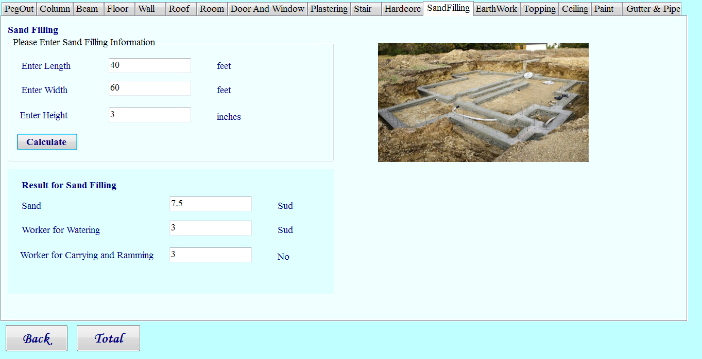

**Figure 3.37 Viewing Result of Sand Filling Form**

**3.5.13 Calculate Earth Work Form**

When the estimator can enter the calculate page, he /she can see the calculate earthwork form. In this page the estimator must enter the earthwork information (length and width, height). And then he /she may click the calculate button. This form is shown in figure 3.38. After that he / she can see the number of worker for earthwork. The corresponding output will appear in figure 3.39.

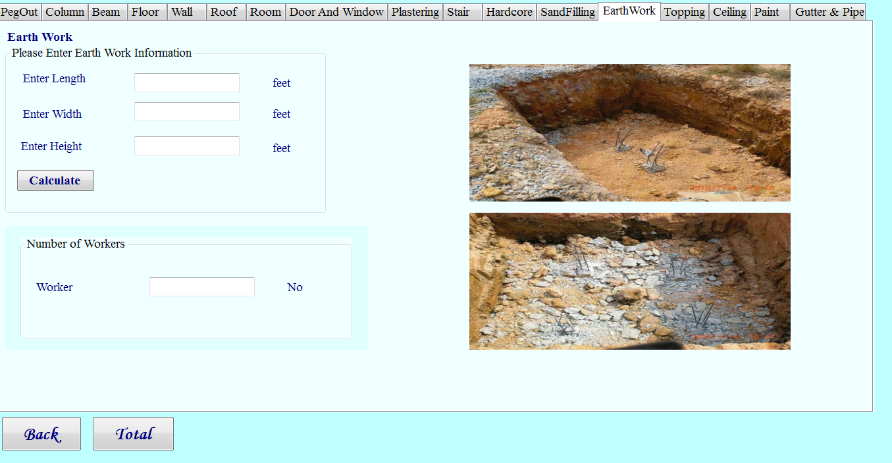

**Figure 3.38 Calculate Earth Work Form**

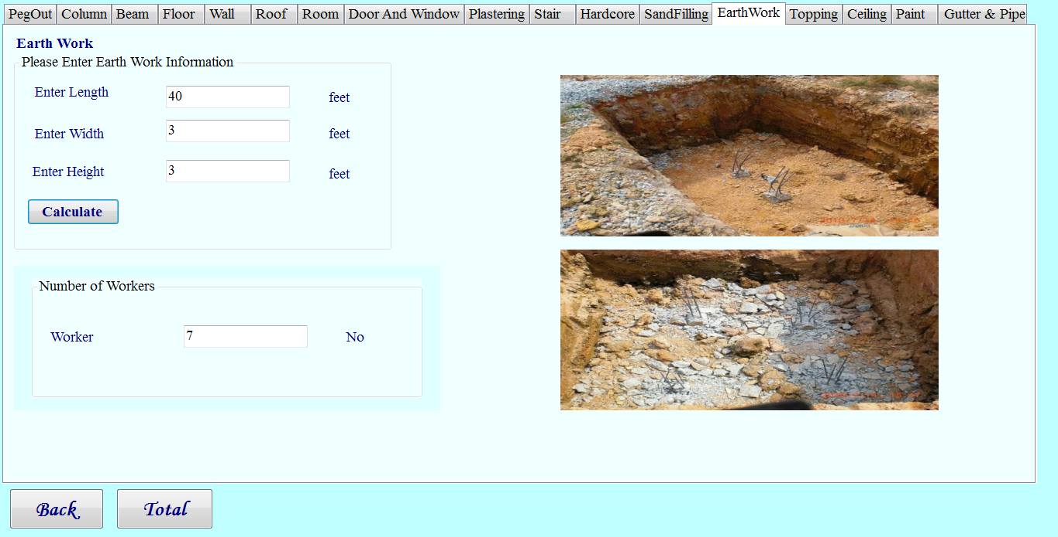

**Figure 3.39 Viewing Result of Earth Work Form**

**3.5.14 Calculate Topping Form**

When the estimator can enter the calculate page, he /she can see calculate the topping form. In this page the estimator must enter the topping information (length and width). And then he /she may click the calculate button. This form is shown in figure 3.40. After that he / she can see the number of raw materials for topping such as number of cement, number of sand, number of aggregate and number of worker. The corresponding output will appear as shown in figure 3.41.

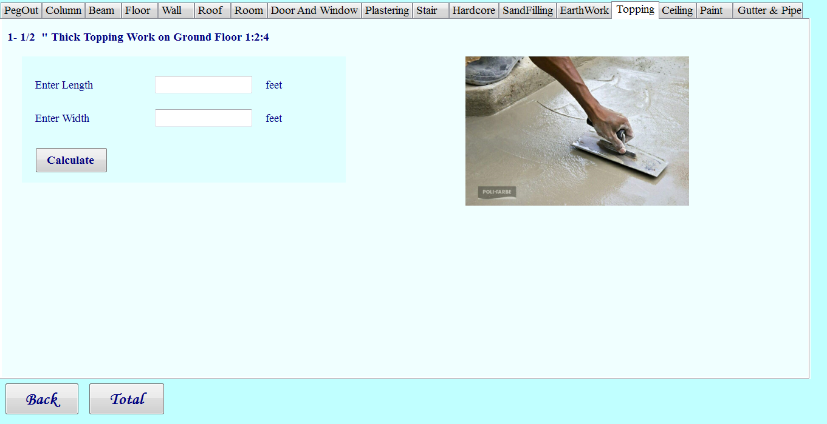**Figure 3.40 Calculate Topping Form**

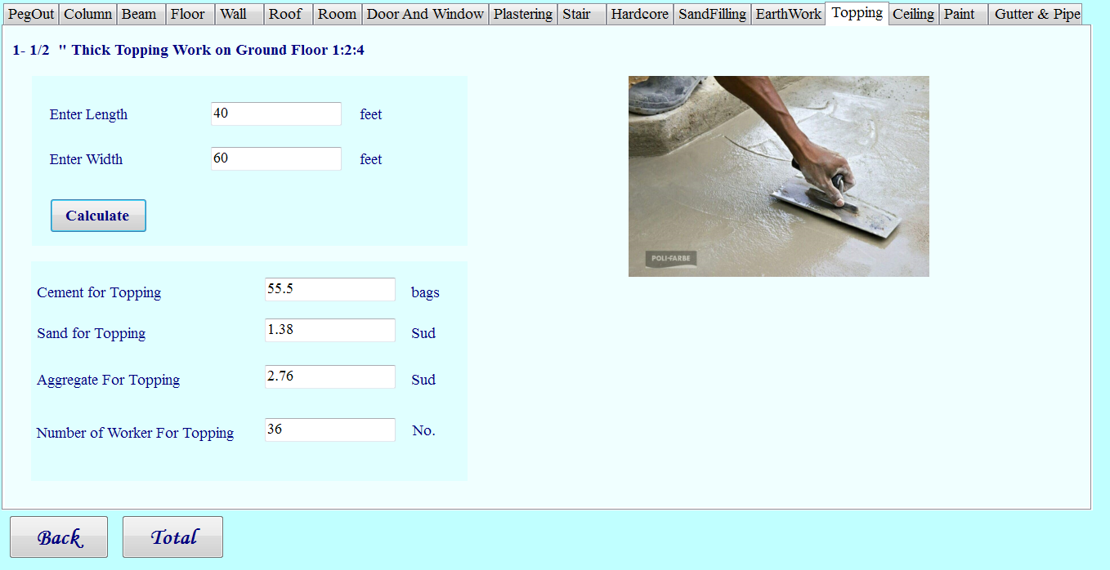

**Figure 3.41 Viewing Result of Topping Form**

**3.5.15 Calculate Celling Form**

When the estimator can enter the calculate page, he /she can see calculate the celling form. In this page the estimator must enter the celling information (length and width, 1 sft per rate). And then he /she may click the calculate button. This form is shown in figure 3.42. After that he / she can see the number of price for celling. The corresponding output will appear as shown in figure 3.43.

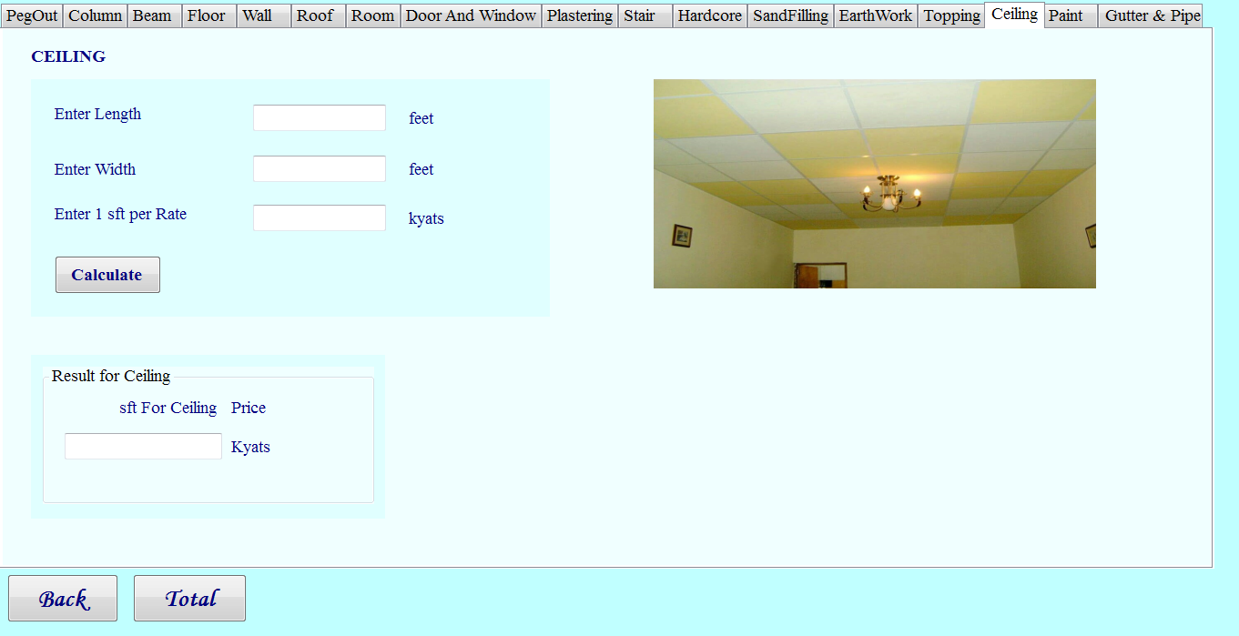

**Figure 3.42 Calculate Celling Form**

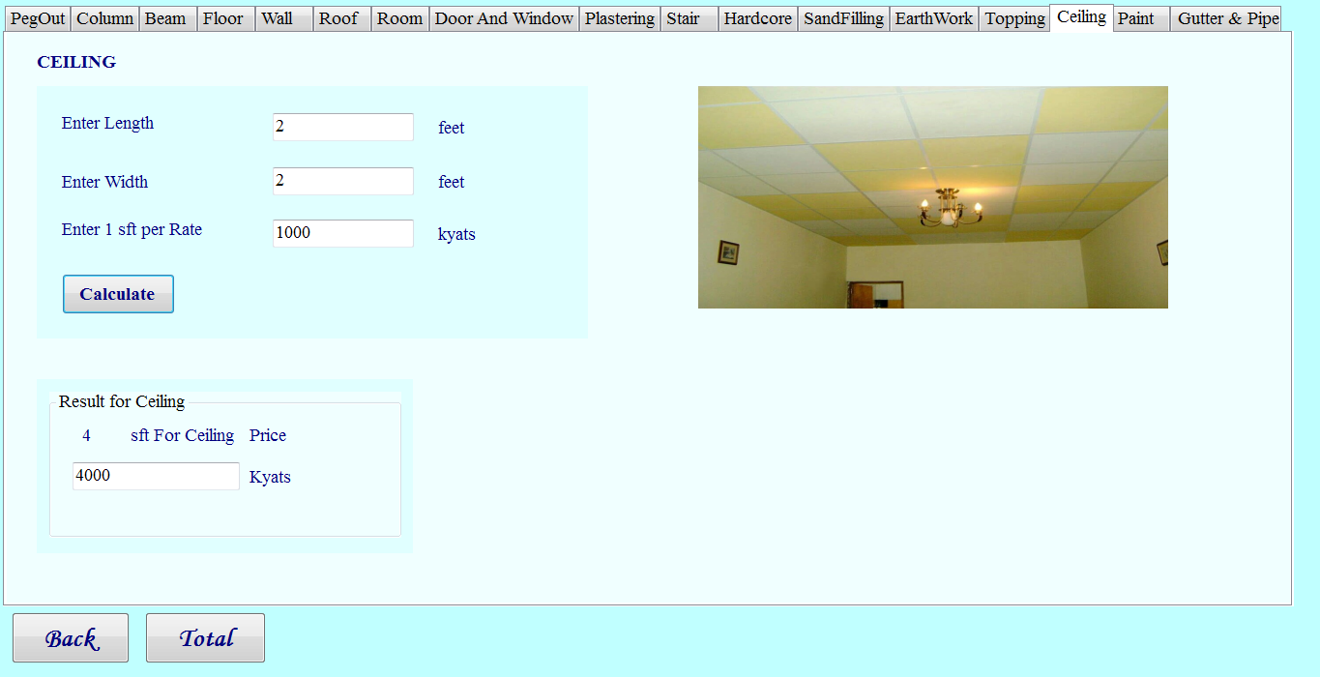

**Figure 3.43 Viewing Result of Celling Form**

**3.5.16 Calculate Paint Form**

When the estimator can enter the calculate page, he /she can see the calculate paint form. In this page the estimator must enter the paint information (length and width, 1sft per rate). Moreover, he or she can choose emulsion paint or oil paint. And then he /she may click the calculate button. This form is shown in figure 3.44.After that he / she can see the number of price for paint. The corresponding output will appear as shown in figure 3.45.

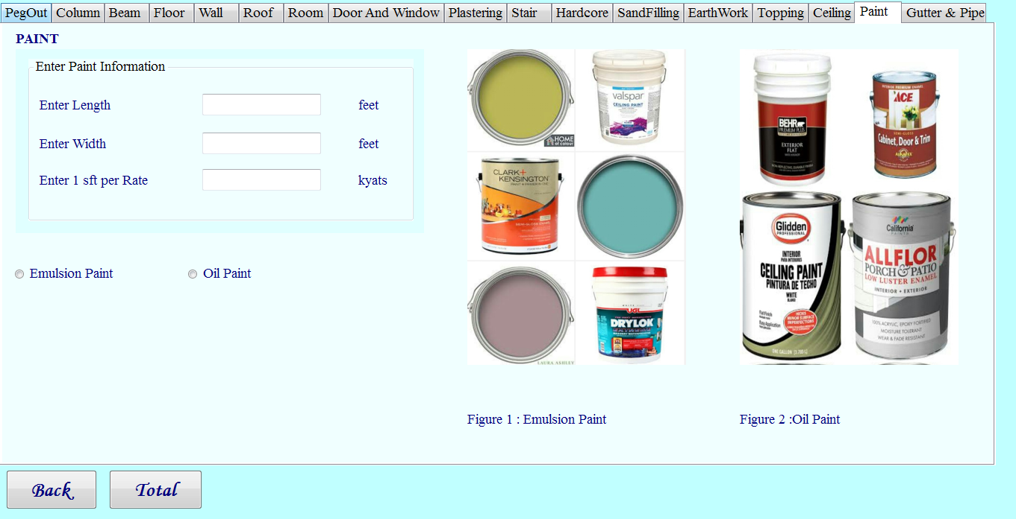

**Figure 3.44 Calculate Paint Form**

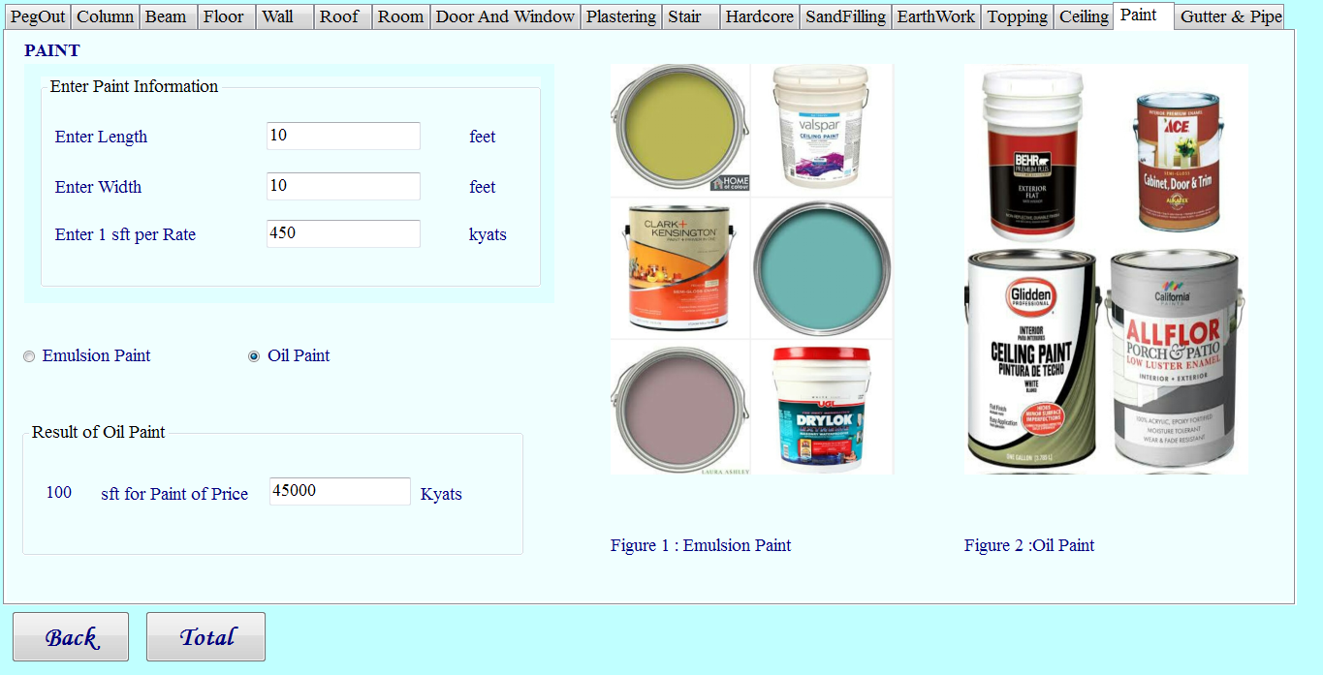

**Figure 3.45 View Result of Paint Form**

**3.5.17 Calculate Gutter & Pipe Form**

When the estimator can enter the calculate page, he /she can see the calculate gutter & pipe form. In this page the estimator must enter the gutter & pipe information such as readymade gutter (width, length), gutter bracket (distance between gutter bracket), pipe (desire height, number of pipe, pipe length, distance between pipe click). And then he /she may click the calculate button. This form is shown in figure 3.46. After that he or she can see the number of raw materials for gutter & pipe such as gutter bracket, PVC pipe and pipe click. The corresponding output will appear as shown in figure 3.47.

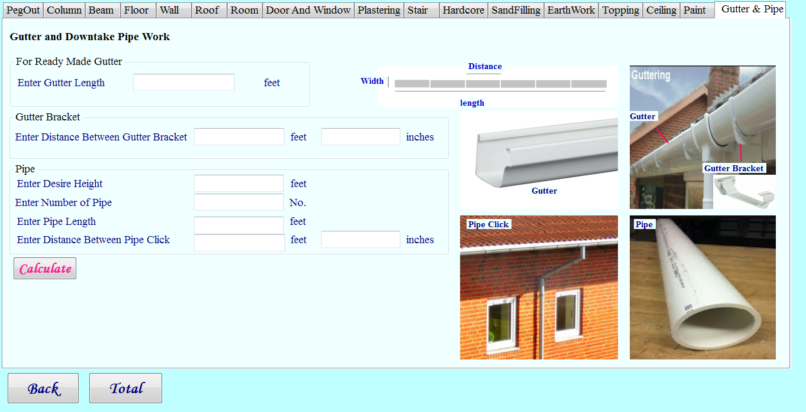

**Figure 3.46 Calculate Gutter & Pipe Form**

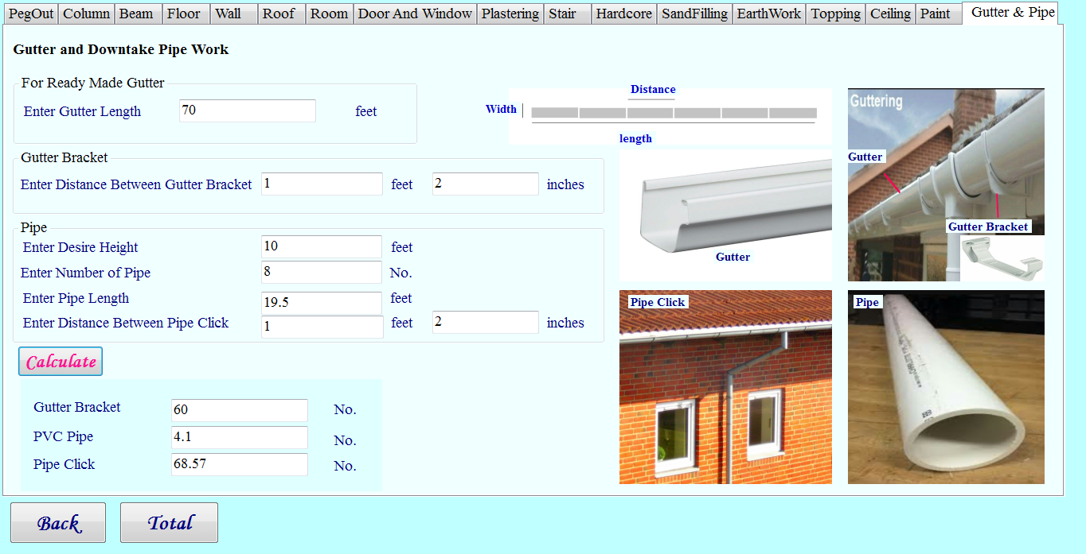**Figure 3.47 Viewing Result of Gutter & Pipe Form**

**3.5.18 Calculate Estimating Cost of Building for Single _Storey Result Form**

In the figure 3.48, this form will be appeared when the estimator can view the result of estimating cost of building for single _storey. After completing using the services, he or she can back to the home page.

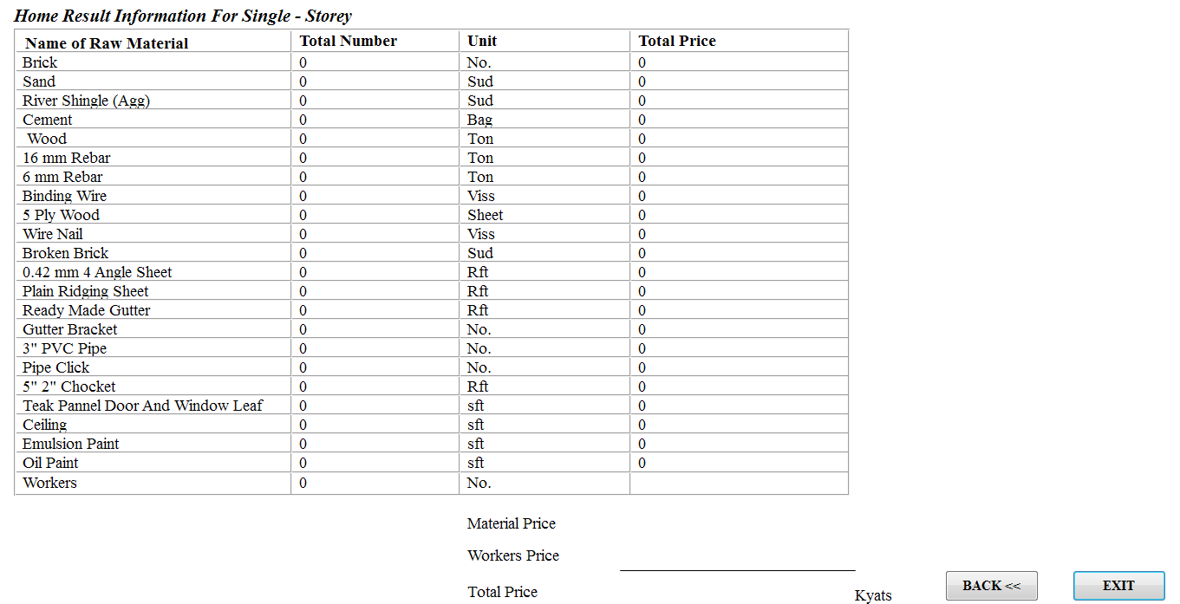

**Figure 3.48 Viewing Result of estimation cost of building for single _storey2**

**3.6 Edit Member form**

The estimator’s edit login page will be shown as in Figure 3.49. In this page, he/she can view the estimator’s function overview. As an estimator, he/she can upload new information, edit and delete login information. After completing using the services, he/she can back to the home page.

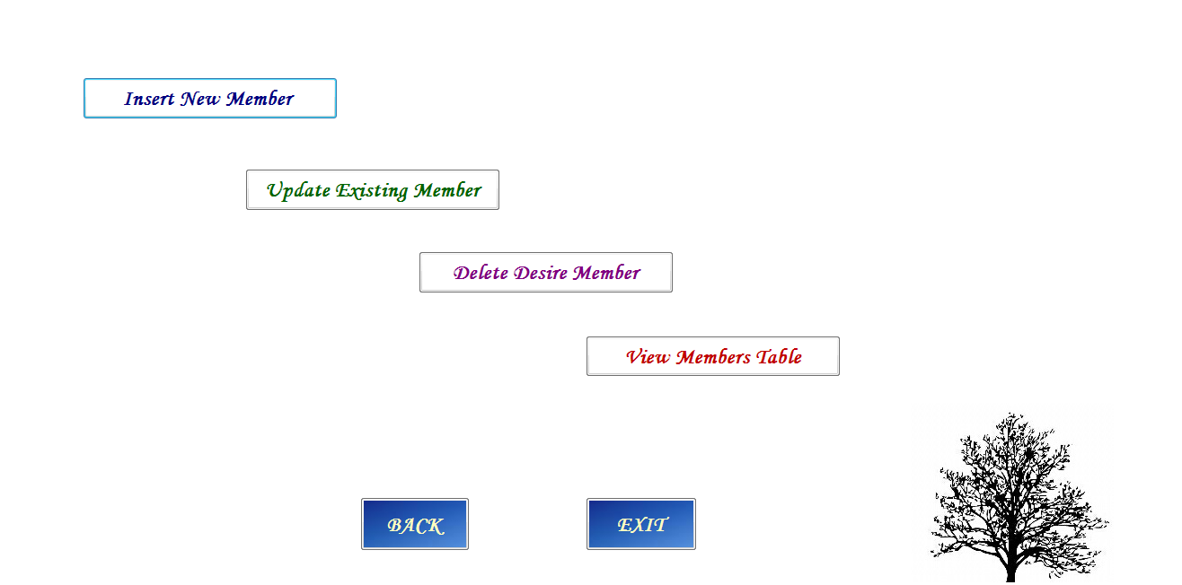

**Figure 3.49 Edit Member Form**

**3.6.1 Insert new Member form**

The estimator’s insert new member information page will be shown as in Figure 3.50. In insert new member page, the estimator can add new information. He/she must fill out the insert new member form. Then he/she must click **Save** button to insert the information of new member. To insert new information, he/she must need to fill the related form and then must click **Save** button. The corresponding output will appear as shown in figure 3.51.

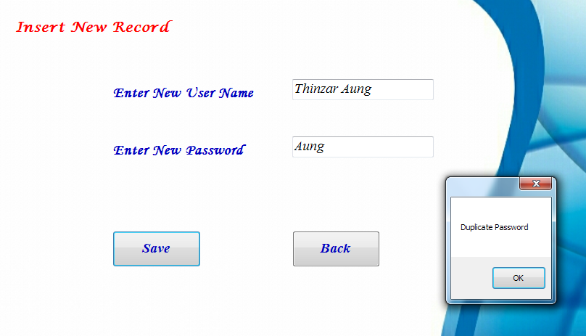

**Figure 3.50 Insert new Member form**

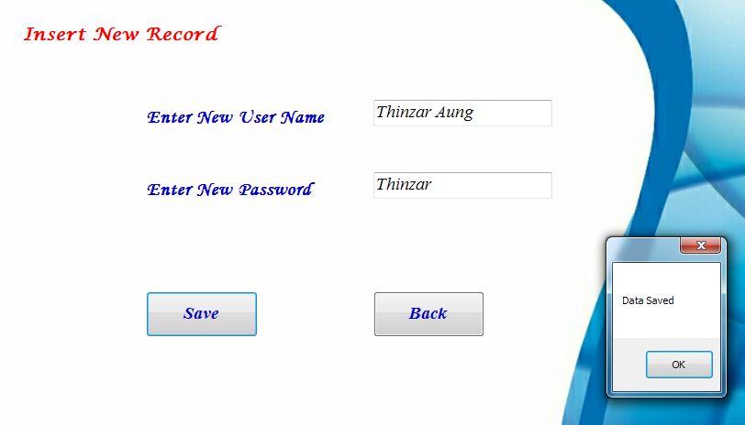

**Figure 3.51 Viewing Result of Insert new Member form**

**3.6.2 Edit Member form**

In the edit member page as shown in Figure 3.52, the estimator can choose “ Change Name” and “ Change Password” radio button. And then he/she can enter existing user name, existing password and new user name or password. After that he/she can click the “Update” button. And then the corresponding output will appear as shown in figure 3.53.

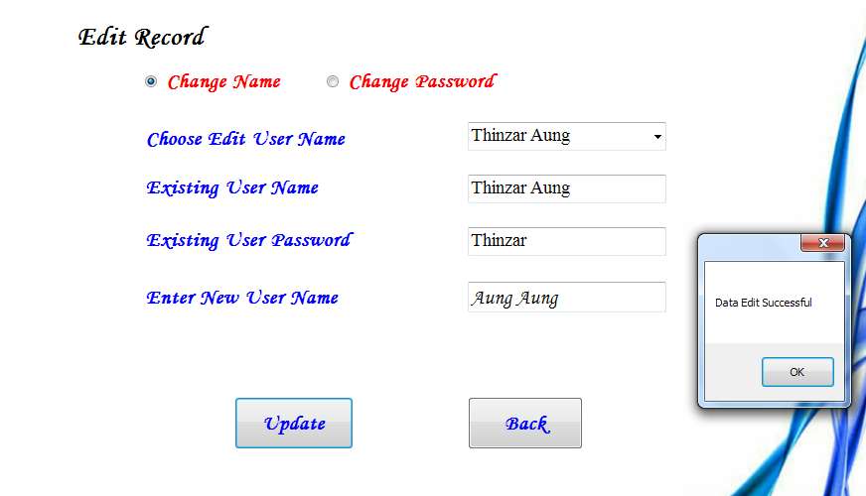**Figure 3.52 Edit Member form**

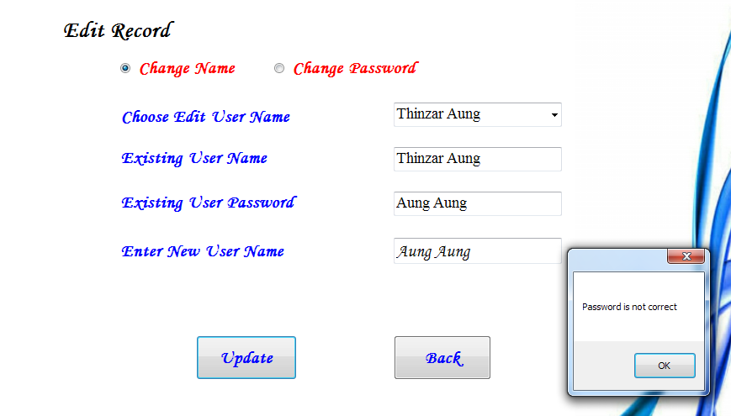

**Figure 3.53 Viewing Result of Edit Member form**

**3.6.3 Delete Member Form**

In the delete page as in Figure 3.54, the estimator wants to delete member record, he or she click **Delete** button.

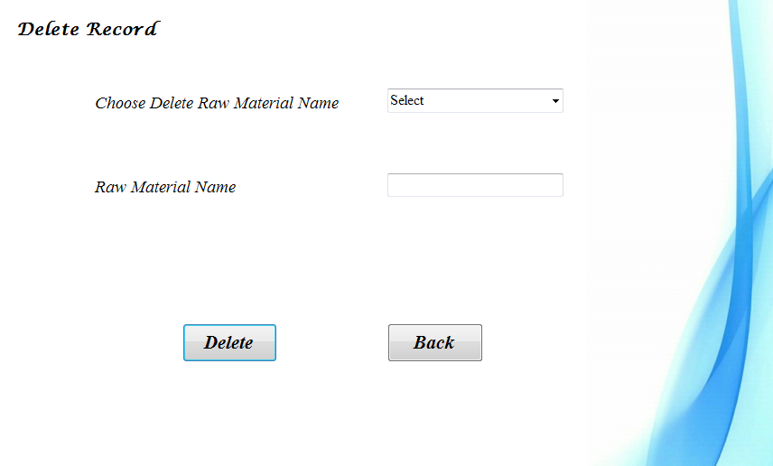

**Figure 3.54 Delete Member form**

**3.6.4 View Member Table Form**

In the view member table page as in Figure 3.55, the estimator wants to view member record. After that he or she can back to the edit member home page.

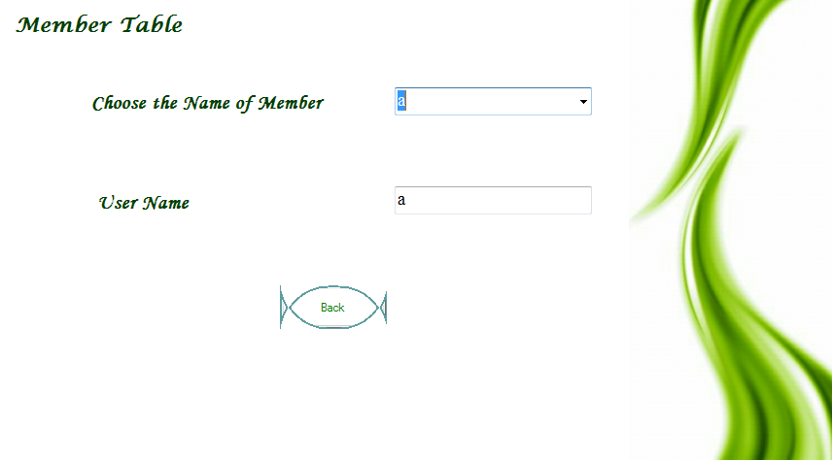

**Figure 3.55 Viewing Member Table form**

**3.7 About Us Form**

In the about us form as in Figure 3.56, it displays the purposes why we would implement the estimating cost of building for single _storey system. Besides, we also show our team members with respect to profile information. If the user wants to view the detail profile information of each team member, he or she must click “About Us” button.



**Figure 3.56 About Us Form**

**CHAPTER 4**

**CONCLUSIONS**

Estimate for the cost of facility construction are a major part of the cost estimate domain. Earlier estimators are prepared by differing methods by estimators and others to support the planning process and to compare with bids. One way to make those estimates is by determining the resources needed (eg. The amount of construction material quantities that are required) and then multiplying the estimated construction material quantities by the corresponding unit cost. Our system can help difficulties of obtaining single storey information. By using this system, we can safe time, money and human efforts. Our System can also help estimator to safe time and paper works (doesn’t need to calculate manually).

**4.2 Limitations**

* Our system only intend to support Estimator for building single _ storey.
  1. **Further Extension**
  + Our system can be extended for two _storey and more.
  + We can extend this system in order to support both English and Myanmar Language.
  + We can extend to support home decoration.